What does this source tell you about life in ancient Egypt?

What do you think it  was used for? | What is it? | What is it made from? | Who might it have belonged to?
 | 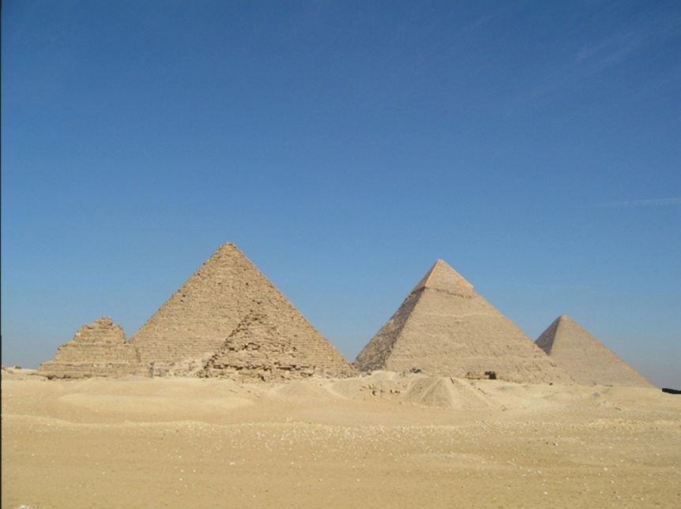
What does it tell  us about? |  |  | Where do you think it might have been found?
 | What would you like to know about it?

