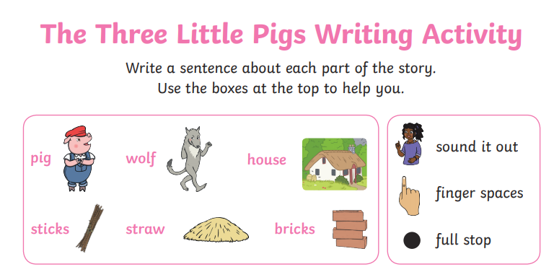

I would like you to write a sentence for each of the pictures and retell the story of The Three Little pigs.

Use the prompts to help you and make sure your sentences are fun and interesting!

<https://www.youtube.com/watch?v=-gdcgnSrUvU>

Part 1









