Special people-

Questions to discuss with a grown up:

- What do you see?
- Where are people going?
- Who is there?
- What are they doing?
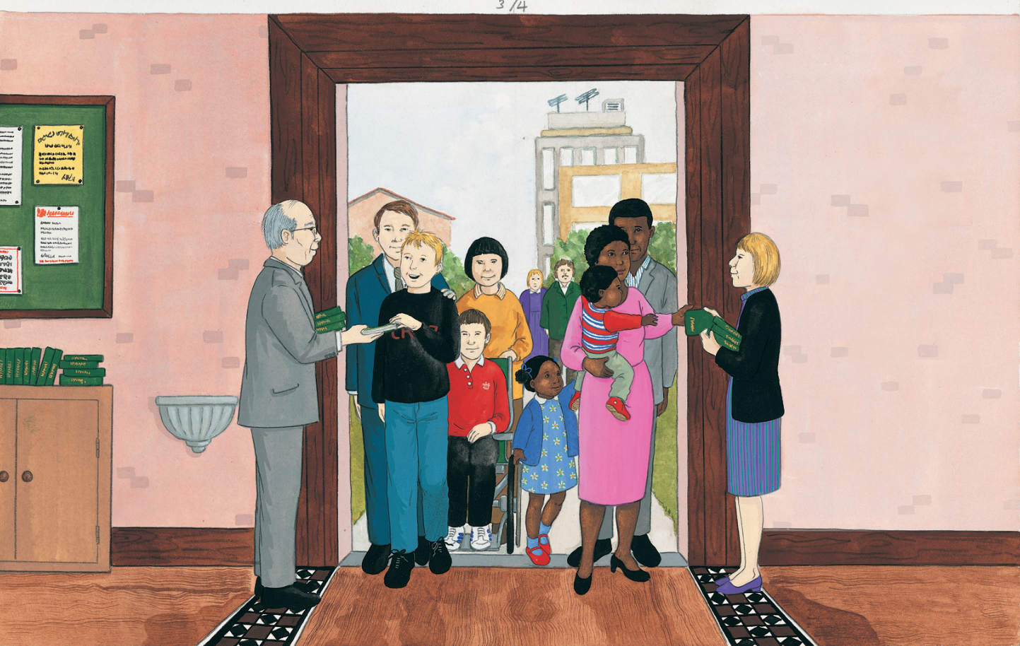
- What other jobs do people do during Mass?

