Use the column addition method to work out the number sentences. Remember to use your fingers if you need to!
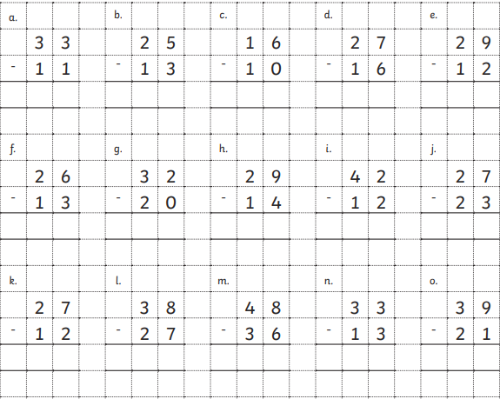

Challenge:
Now try answering these number sentences using column addition:

57 - 17 = 63 - 31 = 43 - 21 =

88 - 26 = 48 - 10 = 69 - 16 =

