Reception Class Tuesday 12th January 2021

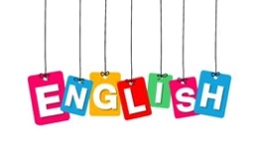

Listen to the story of Goldilocks and the 3 Bears again. https://www.youtube.com/watch?v=0oUP2PFeOi8
Or use the slide show attached.
When you have listened to the story, cut and stick the story into the correct order.

Expressive Arts and Design

Baby bear loves to sleep in bed with his favourite Teddy bear. Do you have a favourite teddy bear? Draw or paint a picture of your teddy bear.

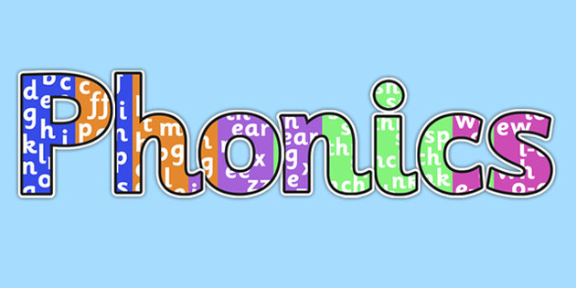

Can you find some objects around your home that start with any of these sounds?:
g, o, c, d
Can you find any that end with ck.

Play the game:
https://www.phonicsplay.co.uk/resources/phase/2/picnic-on-pluto

Maths

Which bowl is the biggest? Which bowl is the smallest?
Which bear is the tallest? Which bear is the shortest?
Cut out and order the pictures from Goldilocks and the 3 bears story from smallest to biggest.
Understanding the World
Goldilocks thought that daddy’s bed was too hard and she thought mummy’s bed was too soft.
Talk to your adult about what hard and soft means.
Can you find some objects in your home that are soft and hard and sort them into two piles.

