Reception Class Thursday 14th January 2021

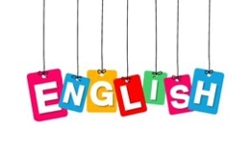

We are going to learn two new tricky words- all & are:
Can you think of and say a sentence using one of these words like these-
“I ate up all of my porridge.”
“We are going on a bear hunt”
Look through a story- book and tell an adult when you find the words all or are. How many can you find?

Expressive Arts and Design

Did you enjoy singing the song about Goldilocks, yesterday?
You could make up some actions to go with your song. Or you could make up a dance.
Have fun and get creative.
Look at the song lyrics about the other characters and enjoy singing about them too.

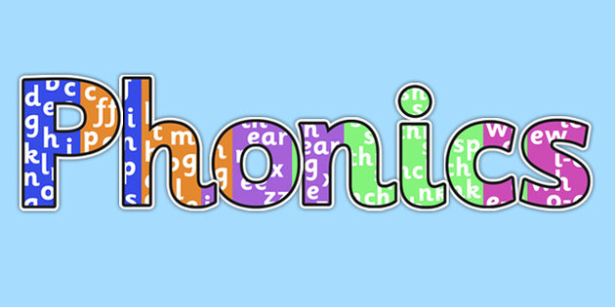

Look through the phase 2 set 1 and 2 sounds on this website:
https://www.bbc.co.uk/bitesize/topics/zf2yf4j

Choose a sound you have looked at today and draw some objects that start with that sound.

Maths

Find a selection of toys- Put them next to each other, which one is taller?
Look in your toy box, find 2 toys:
Can you say “--------- is taller than------“
Can you say “------ is smaller than------“
Can you say” ------- is the smallest/biggest”
Have a look at this website:
https://uk.splashlearn.com/measurement-games-for-year-1
Understanding the World
What bears did you find out about yesterday?
Draw a picture of your favourite bear and write what type of bear it is.
Can you tell an adult some facts about this bear?

