Reception Class Friday 8th January 2021
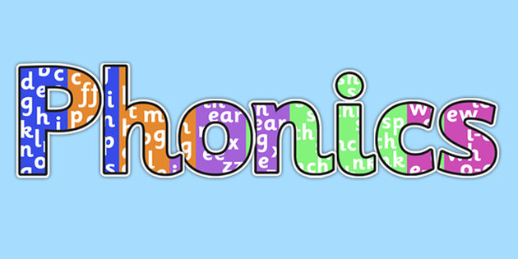

Recap all phase 2 sounds. As you see the letter say the sound.
https://www.youtube.com/watch?v=wxy_zP2F_GU

Complete the activity below.

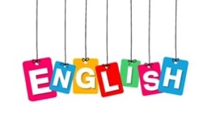
Can you tell your grown up the repeated language that the pigs and wolf
used throughout the story?

We would like you to retell the story of the three little pigs using the masks
that you made.

Think about the repeated language that was used by each character. You could video your retelling of the story so that you can send it to show your family and friends, but do not forget to ask your grown-up first.

Maths

To play the game ‘compare and order’.

http://www.crickweb.co.uk/Early-Years.html

Expressive Arts and Design

Decorate your own pig and wolf mask using the sheet below.

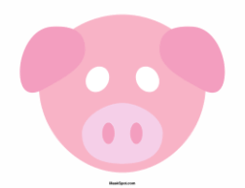
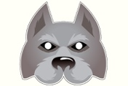

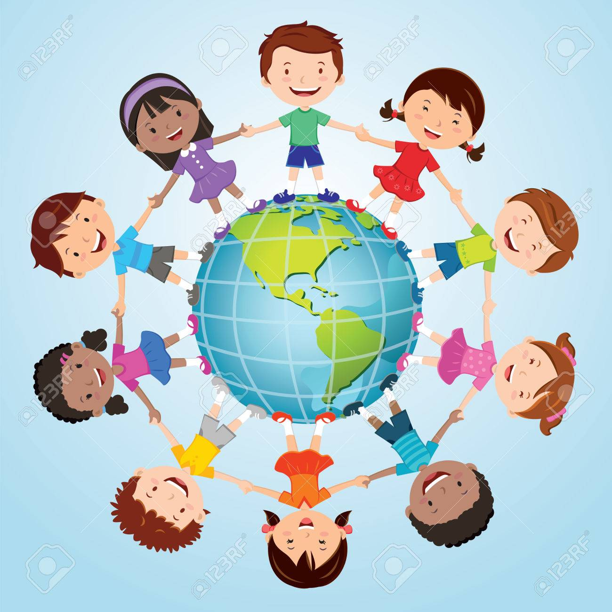 Understanding the World
Play the animal game.
Describe an animal to your grown up

For example:
It has 2 legs, it has feathers, it produces eggs. What could it be?

Think of another animal and describe it to your grown up.

