Reception Class Thursday 7th January 2021
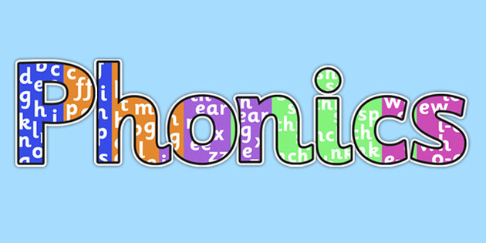
Recap all phase 2 sounds. As you see the letter say the sound.
https://www.youtube.com/watch?v=wxy_zP2F_GU

Complete the activity attached. You need to read the caption and match it to the picture.
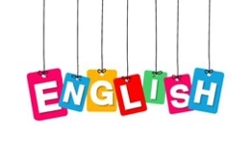
Look below at picture of Big bad Wolf:

Answer these questions with your grown up:

Why did their mother warn them about the big, bad wolf?
What did the wolf look like?
What words can you use to describe the wolf’s face? (description)
How did the wolf behave?

Expressive Arts and Design

Sing Old Macdonald had a farm!
Make a shaker to play whilst you sing.

Follow the instructions to make your own shaker!
https://www.youtube.com/watch?v=fZjywurvgEE

Maths

Gather all the people who live with you in your home. Now put them in order of size! Were you the smallest or the biggest?

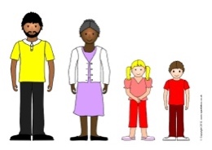

Understanding the World

Do some research on pigs and
create a mini fact file about them. You can find out; what they eat? what do you call a male and female pig? What noise do they make?
Add any other interesting facts you find out about them.

