Reception Class Wednesday 6th January 2021
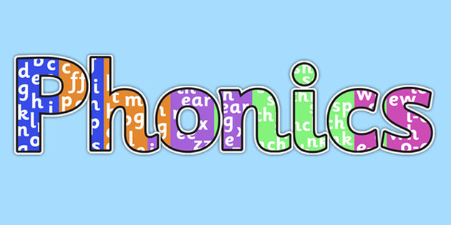

Recap all phase 2 sounds. As you see the letter say the sound.
https://www.youtube.com/watch?v=wxy_zP2F_GU

We have learnt the following diagraphs
sh, th, ch, ng

Use your sounds to identify the words on the next page.
Now look through some of your books at home and see if you can find these diagraphs in words.

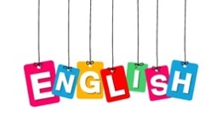

Listen to the story of the Three little pigs. If you have the storybook at home
The ask an adult to read it to you. If not watch the story on the internet using the link
Link below.
https://www.youtube.com/watch?v=QLR2pLUsl-Y
Have a go at answering these questions:
How many pigs were there? Where did they live? Who did they live with? Where did they go? Who did their mother warn them about? What did they do after they had left their mothers house? What materials did they make their houses out of? Which house did you think was best and why?

Maths

Complete the ICT game. You have to compare sizes using mathematical language.

https://www.topmarks.co.uk/early-years/lets-compare
Or

Find some cuddly toys and order them from smallest to biggest.

Expressive Arts and Design

Look through the recycling for empty boxes, tubes, bottle tops etc. You will also need some sticky tape. Can you build a home for one of the pigs? Remember to include a door and some windows.

Take a picture of it as we would love to see if when you return to school.

Understanding the World

Identify the animals that make these sounds!
Did you spot the pig? What sound does a pig make?
https://www.youtube.com/watch?v=Xkto4xVKFhc

ship | with | thin
chip | long | shell
chop | shed | song

