Reception Class Tuesday 5th January 2021
Hello Reception class! Hope you had a lovely Christmas! It is such as shame that we cannot be back at school just yet, but hopefully it will not be too long, and we can catch up about the fun you have had over Christmas. Below are activities that you can complete each day at home. Our new topic is Traditional Tales. Take care and keep working hard. From Mrs Barnett and Mrs Richards

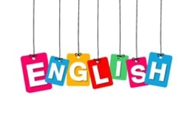

Once you have drawn the picture of one of your Christmas gifts you can now
Have a go at writing a simple sentence to say what it is.
You may want to use an alphabet mat to help you form your letters correctly.

Encourage your child to write the sentence; I got a ……….
Instead of them copying the sentence, ask them to say each word slowly and listen for the sounds they can hear. It does not matter if they only hear and write down a few sounds in the words. This is all good practise in helping them to write as well as building up independence.

Expressive Arts and Design

Christmas gifts

Draw a picture of one of your Christmas gifts.
Do not forget to colour it in. You could use pens, pencils or even paint.

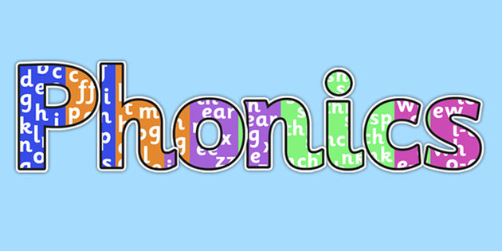
Recap all phase 2 sounds. As you see the letter say the sound.
https://www.youtube.com/watch?v=wxy_zP2F_GU

We have learnt the following diagraphs
sh, th, ch, ng

Complete the attached activity.

Maths

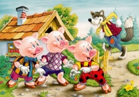
In maths we will be looking at ordering size. Below are the three little pigs. Can you order them from smallest to biggest? Cut them out and stick them in order.

Understanding the World

Do you have some farmyard animals at home? Get them out and set up your farm. Find out which animals provide us with milk, eggs, meat. You can either ask a grown up, look in a book or look on the internet to find out.
If you do not have farmyard animals try this website https://www.topmarks.co.uk/Search.aspx?q=farm%20animals
Go to ‘scene maker – The Farm’

