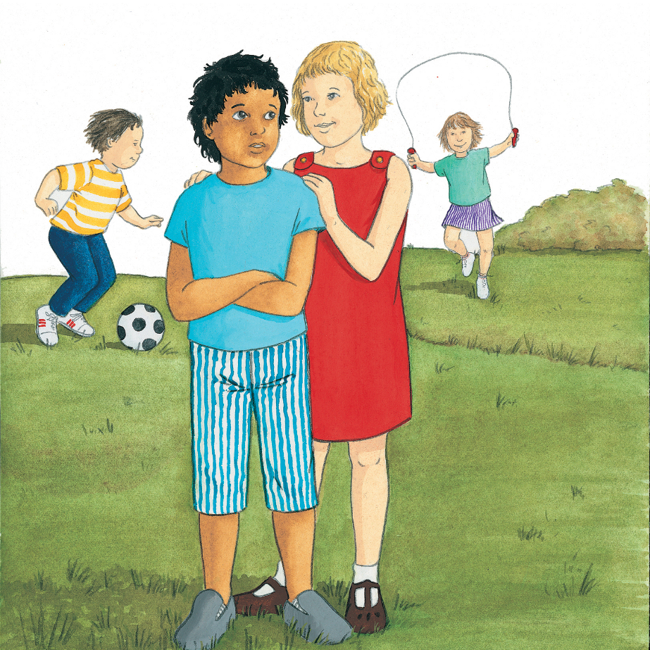

05-01-2021

Religious Education

Discuss with a grown up.

* What do you think has happened in the picture?
* How do you think the boy and the girl feel?
* How do you know?
* What choice has the girl made?
* What do you think happens next?
* When have you had to make choices like that?
* What helped you?
* What good choices have you made?
* How did you feel?
* What happens when you make a wrong choice?
* How do you feel, then? How can you try to make it right?