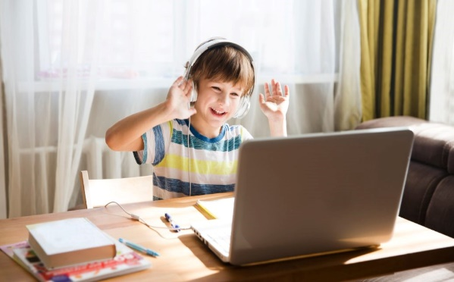

Setting Up A Safe Workspace at Home

Here we are again, lockdown has thrust us all into the world of home-schooling again.
The more time your children spend at the computer, the more likely it is they are slouching or sitting in some nightmare–of–a–posture. School classrooms may be designed for children, but our kitchen and dining room tables are not.
Here are a few guidelines / tips that may help.

Organise
- Have items that the child uses most, placed nearby so they do not have to bend or twist their body or neck unnecessarily.
- Ensure your child is up and dressed appropriately for lessons.
- Ensure your child has had something to eat and drink before lessons begin.

Computer screen
- Place the computer screen directly in front of your child.
- Make sure their eyes are level with or just below the top of the screen.
- Your child must be able to comfortably view the screen without having to noticeably tilt their neck forwards or backwards.
- If need be, raise the height of the screen by placing on a book / ream of paper etc
- The screen should be placed about an arm’s length away from where they are sitting.

Keyboard
- The mouse and keyboard should be positioned close together and in front of your child.
- When using a desktop computer, centre the letters on the keyboard in front of your child, not the entire keyboard.
- Place the keyboard in a position where their shoulders and arms are relaxed, and their forearms are resting on the desk / table.

Furniture and Equipment
- Use a chair with good lumbar support. A rolled–up towel placed behind their lower backs also works well. Use a pillow to raise them up to the proper height if needed.
- The edge of the chair seat should not compress the backs of your child’s knees.
- Their thighs should be supported and parallel to the floor.
- Make sure your child is working on a stable surface.
- Their elbows should be at the same height as the desk.
- Their feet should be flat on the floor. Make use of a footrest if your child is too short. A box or a storage crate will do nicely if you do not have a footrest available.

Laptops
- Encourage children to set up their laptops in a way similar to that of desktop computers. Laptops should be used on tables and desks and never on the lap. Sitting on the floor or chilling out on the bed or couch is a definite no-no.

iPads
- If children are using an iPad an angled book holder may help with proper positioning and help prevent having to look down for extended periods of time. If you have a cookbook holder – this would suffice.

Distractions
- Try to eliminate distractions such as the television, background noise and mobile phones. Wearing earphones may assist your child to concentrate however the volume should be monitored to ensure it is not too loud.

Glare–free Screen
- Check that the computer screen is free from glare spots. You may have to reposition the screen or adjust the lighting in the room.
- Make sure your child avoids straining their eyes by taking frequent breaks. They can cover their eyes with their palms or look away from the screen.

Safeguarding
- Please ensure you are in the room when any online live lessons are planned.
- Ensure you are aware of the timings and dates of online live lessons and your child has all the resources required.

Health & Safety
- Make sure any trailing cables are covered or laid so not to cause a trip hazard.
- Do not overload sockets / extension leads and switch off all electrical appliances after use.
- Do not allow iPad and laptops to be used in bed.
- Restrict computer time (after spending time online lessons) and encourage other activities.

And lastly…

Make sure your child takes a break and moves every 30 minutes.
Here are ideas for some quick movement breaks:
- Stand and stretch arms overhead. Grasp hands, interlocking fingers, flip palms up to the ceiling and stretch.
- Bring arms behind your back at hip level, grasp hands and try to pull shoulder blades down and together.
- Stand with hands against the wall, place one leg back with knee straight and foot flat on the floor. Keep your body straight like a board, lean into the wall and stretch the back of the calf. Repeat on the other side.
- Stretch your neck from side to side. Jump up and down and shake your hands.
- Go outside and get some sunshine and a good dose of vitamin D

Contact
- If you have any concerns or need assistance with this guidance, please contact the school at admin@stsaviours.lewisham.sch.uk
