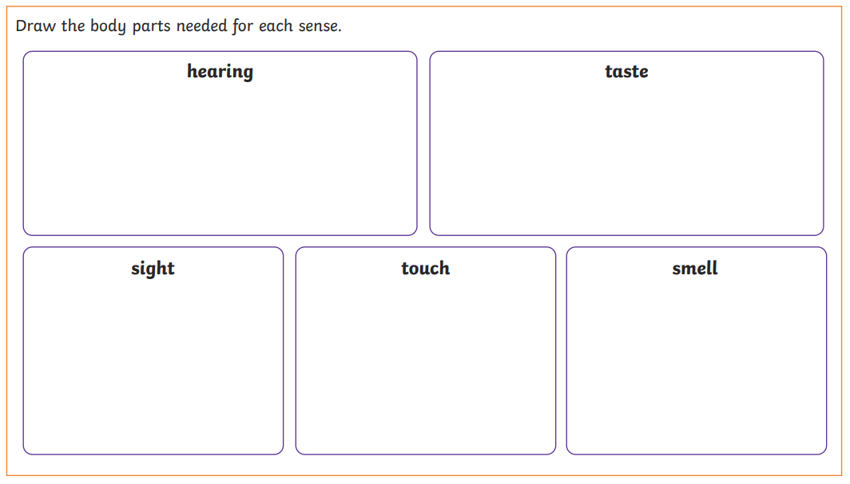
My five senses
Your task for today is to write down all the different things you can hear, see, touch, smell and taste today!
You will be surprised at how often we use our senses.

