Counting in 2’s
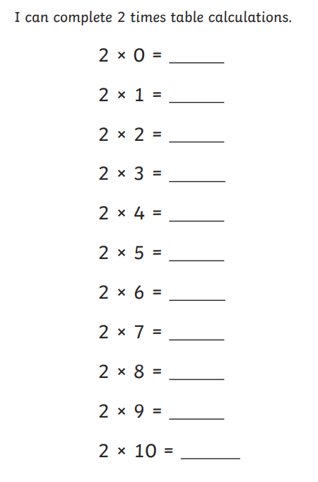
https://www.youtube.com/watch?v=GvTcpfSnOMQ

Counting in 5’s
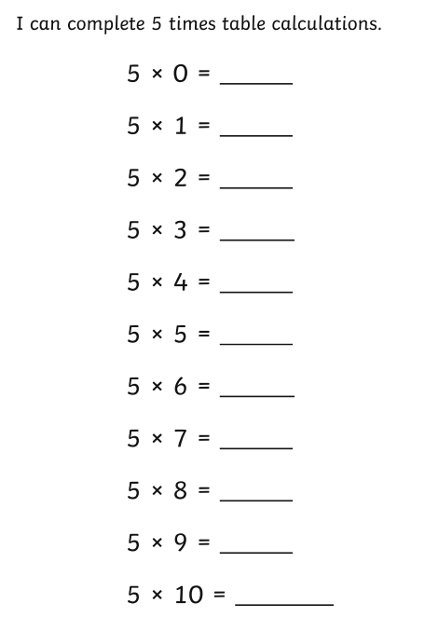
https://www.youtube.com/watch?v=EemjeA2Djjw

Counting in 10’s
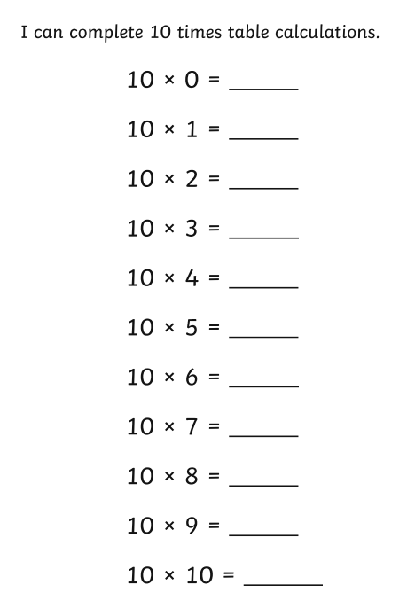
https://www.youtube.com/watch?v=Ftati8iGQcs&list=PLM95cb_Szq3am4n6jJw127QbBlDivZgIc

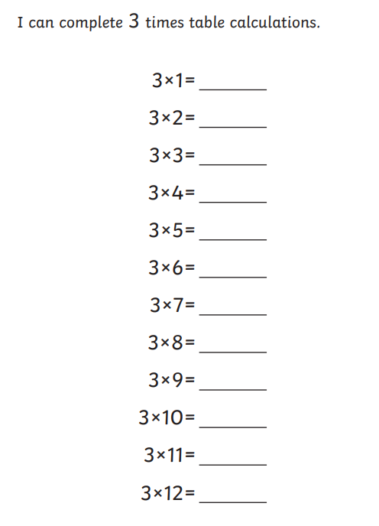
Challenge

