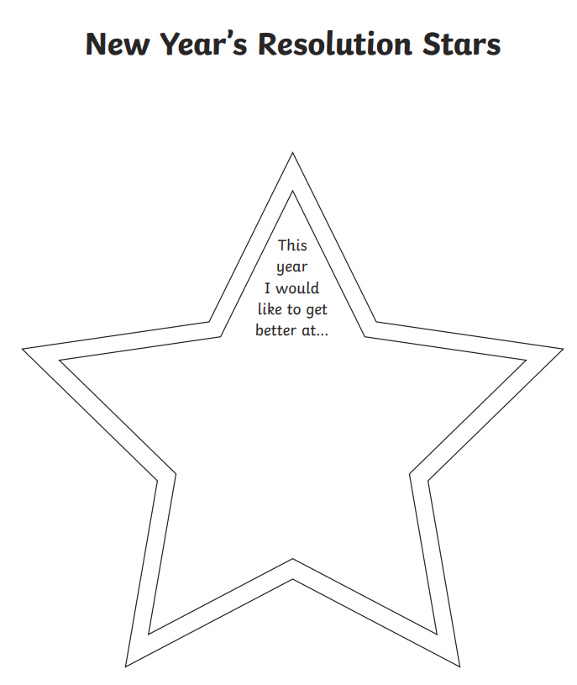

_____________________________________________________________________________________________________________________________________________________________________________________________________________________________________________________________________________________________________________________

_____________________________________________________________________________________________________________________________________________________________________________________________________________________________________________________________________________________________________________________

We have not long entered 2021!

I would like you to think back to last year and think about what you would like to improve on this year.

I would like to read more so my New Years Resolution will be to get better at reading and read more books this year. What is your New Years resolution?