Reception Class Monday 11th January 2021
Hello Reception Class! We hope you are all keeping well. We are missing you all very much and are so proud of how hard you are working at home. Next week we hope to see how you’re getting on when we launch the online teaching and learning platform -Microsoft teams. Our topic is called Traditional Tales and each week we will be looking at a different traditional story.
This week our Traditional story is Goldilocks and the 3 Bears. Look at the slide show of the story or watch the video https://www.youtube.com/watch?v=0oUP2PFeOi8. If you have your own copy, you could read that too. Then you are ready to try the activities we have set for you.
Take care and enjoy the learning. From Mrs Barnett and Mrs Richards
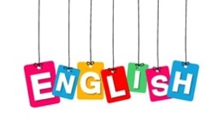

Listen to the story of Goldilocks and the 3 Bears.https://www.youtube.com/watch?v=0oUP2PFeOi8
Once you have listened to the story, ask your child the following questions:
- What did Goldilocks decide to do when nobody answered the door?
- What did Goldilocks find first? What did she do?
- Why didn’t Goldilocks like the porridge?
- What did she find in the living room?
- Why didn’t she like sitting in daddy bear’s chair?
- What did Goldilocks do when she got into baby bear’s bed?
- What did the bears say when they got home?
- How did Goldilocks feel when she saw the bears? What did she do?

Expressive Arts and Design

Goldilocks ate the bears’porridge!
Find 3 bowls and 3 spoons and some porridge oats. Pretend to make porridge for the 3 bears. If you have a doll, you could pretend that she is Goldilocks and say:
“This porridge is too hot!”
“This porridge is too sweet”
“Mmmmm, this porridge is just right”

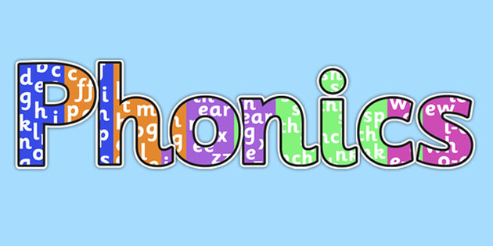
This week in Phonics, we would like to continue recapping all the sounds we have learnt so far. We will introduce new sounds next week.
Look at the phase 2 sounds and say them:
https://www.phonicsbloom.com/uk/game/flash-cards?phase=2
Can you look around the house to find an object that starts with one of these sounds? S, A, T, P, I, N
Can you find any objects that end with these sounds?

Maths

In maths we will continue to look at size. Find objects around the home or some of your toys and encourage your child to compare them. Ask questions like
“Which one is the …….
biggest/smallest/shortest/tallest/widest/thinnest/
longest”
Can you put them in order from smallest to biggest?
Understanding the World
Do you like porridge? What is your favourite topping?
Try making some porridge with a grown up. You could try using different toppings. You could try some jam, some fruit or some honey.
Encourage your child to look at the porridge oats before and after they are cooked. Talk about what you notice happens.

