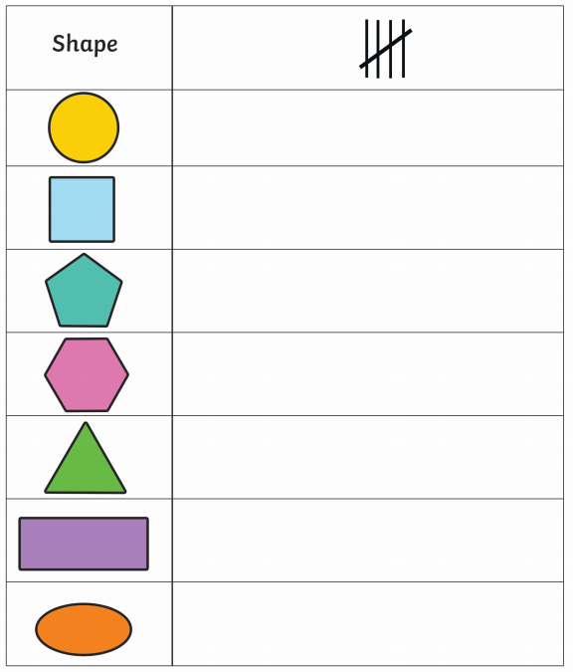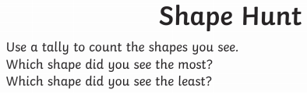

05-01-2021

I found ________ the **most**.

I found ________ the **least**.

2D Shapes:

Cut out or draw the shapes in the box.

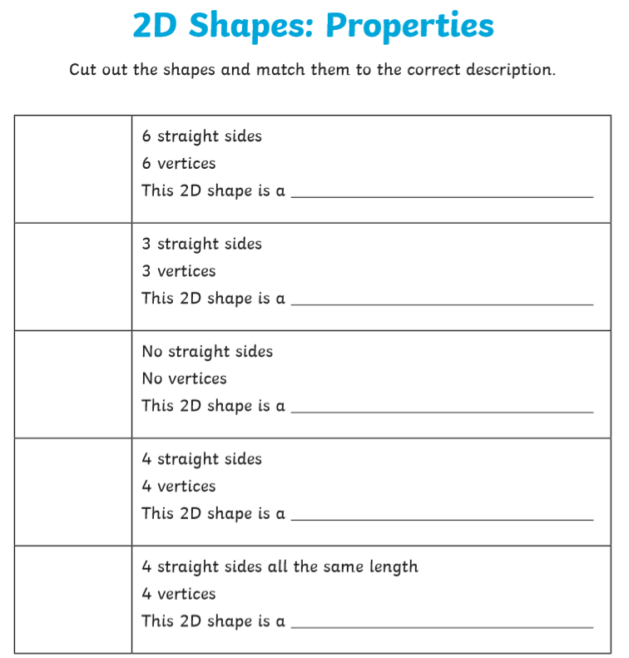

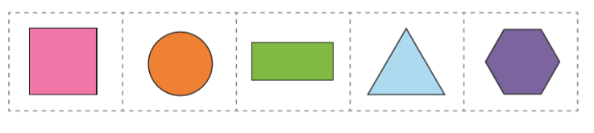

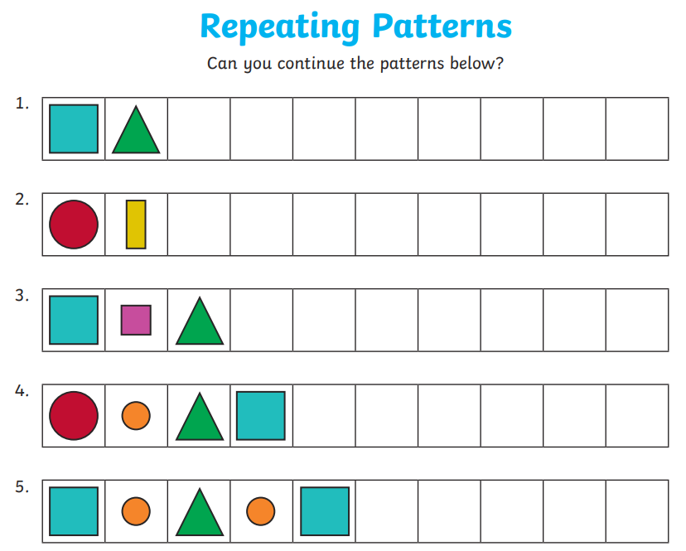

|  |  |  |  |  |  |  |  |  |  |
| --- | --- | --- | --- | --- | --- | --- | --- | --- | --- |
|  |  |  |  |  |  |  |  |  |  |

|  |  |  |  |  |  |  |  |  |  |
| --- | --- | --- | --- | --- | --- | --- | --- | --- | --- |
|  |  |  |  |  |  |  |  |  |  |

Have a go at trying your own repeated pattern: