07-01-2021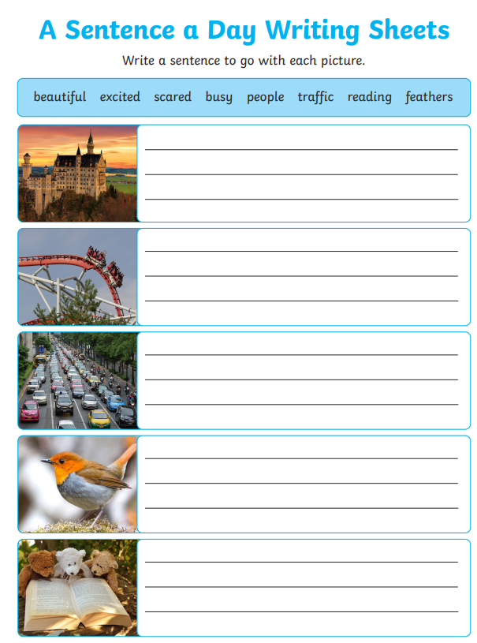

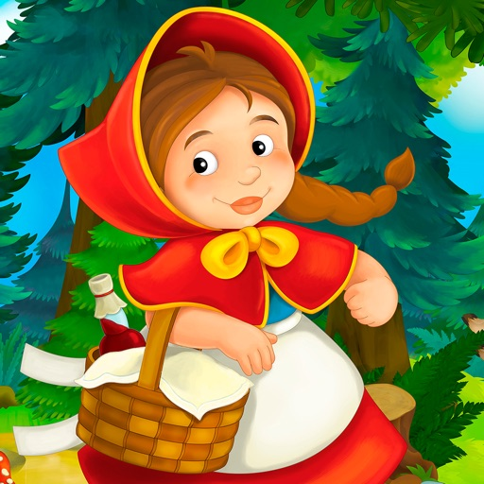
Write your own ending to Little Red Riding Hood, if you could change the ending wat would happen instead?

Here is Mrs’s Squires ending-

Little red riding hood was nearly at her grandma’s wooden door when she heard lots of laughing. She went to knock on the door using the big metal handle but something stopped her and she decided to peep through the window. She quietly tip toed around the side of the house and saw the wolf and her Grandma having a picnic! This amazed Little Red Riding hood and she decided she would join them.

What would happen in the end of your story?
Make sure to draw a picture after you have written your ending.

