I would like you to write a wanted poster for the naughty Big bad wolf.

What did he do? What does he look like?

Use the prompts to help you with your wanted poster!

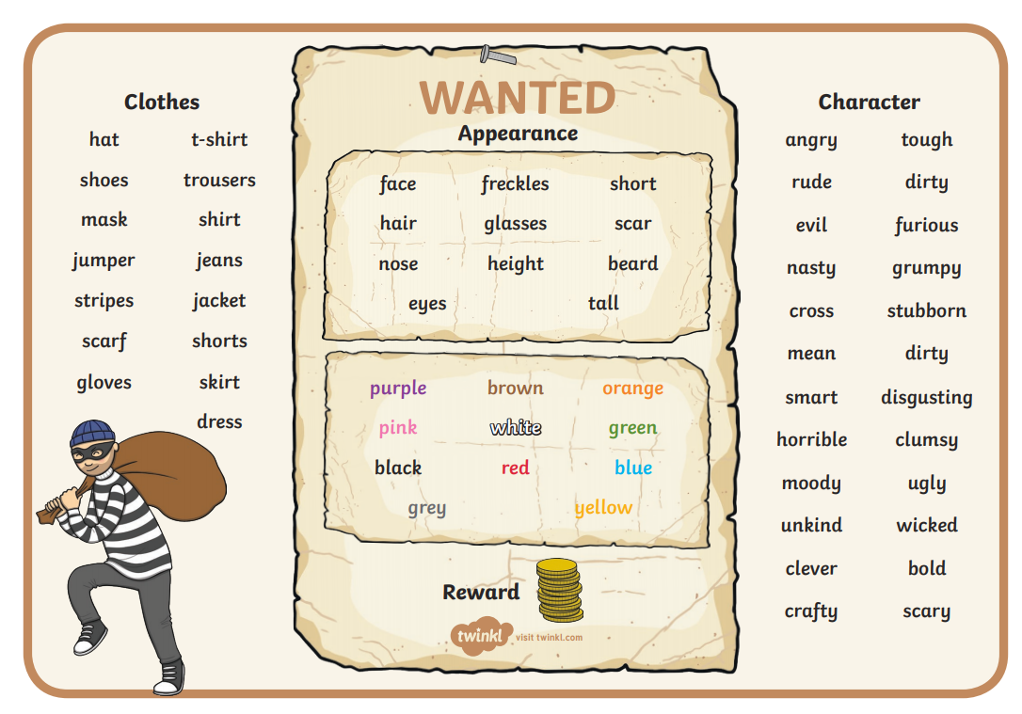

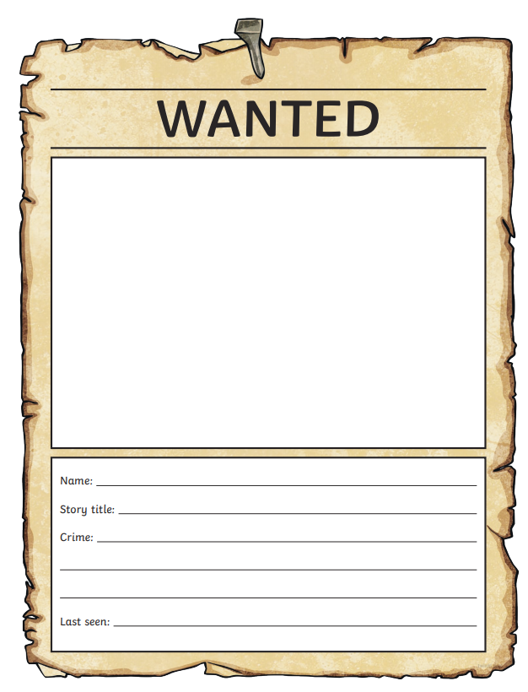

Name:____________________________

What is he or she like:____________________________________

_____________________________________________________

_____________________________________________________

Crime:________________________________________________

__________________________________________________________________________________________________________Reward:___________________________________________________________