Reception Class Friday 15th January 2021

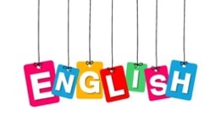

Today we will continue looking at our new tricky words- all & are
Did you find the tricky words all & are in your story- books?

Today we would like you to practise writing these words.
If you have a dry wipe board, you could use this or use a piece of paper and a favourite pencil. Can you write a sentence with one of these words?

Expressive Arts and Design

Can you build a bed perfect for Goldilocks?
You could use lego or building bricks or whatever you have at home.
How will you make it nice and comfortable for Goldilocks? What will you use for a pillow or a blanket?

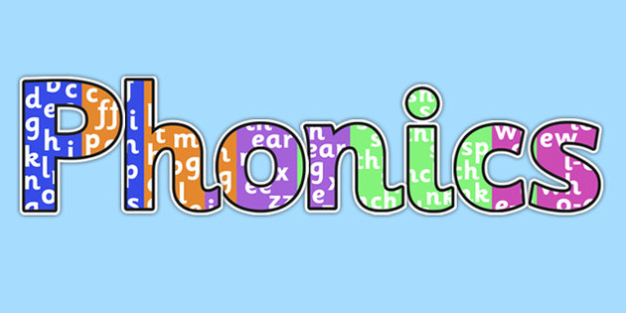
Using our phase 2 sounds we can start to read CVC words. Look at this website to see if you can read the word. Don’t worry if your child cannot read the word, encourage them to say the sound of each letter or the first sound.

https://www.phonicsplay.co.uk/resources/phase/2/pick-a-picture

Maths

Goldilocks broke baby bear’s chair because she was too heavy. What does that mean?
Can you find some heavy things in your home? Which one is the heaviest?
If it isn’t heavy it is light. Which one is the lightest?
Choose 2 objects:
Can you say “------is heavier than------“
Can you say”-----is the heaviest.”
Can you say “-----is lighter than ------“
Can you say ------- is the lightest”
Understanding the World
Go outside for a walk with your family and look at the trees.
Can you find the tallest tree?
Can you find an old tree?
What do you notice about the trees in winter?
Touch the bark of the tree- what does it feel like?
Are your arms long enough to wrap around the tree trunk?

