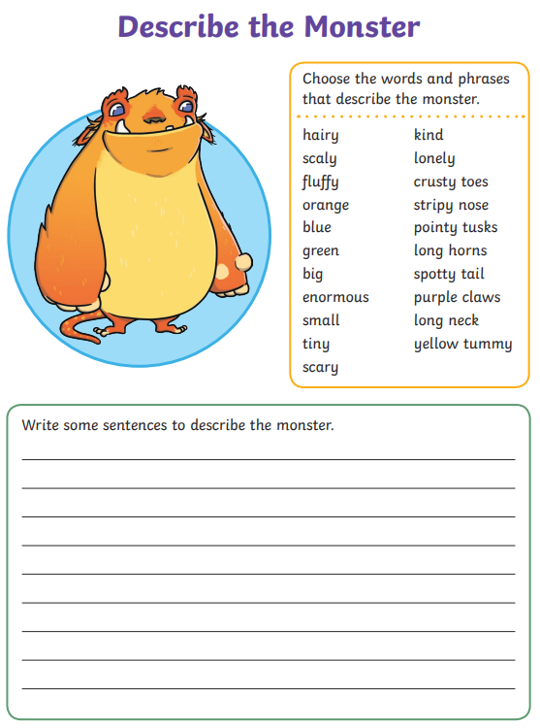

05-01-2021

05-01-2021

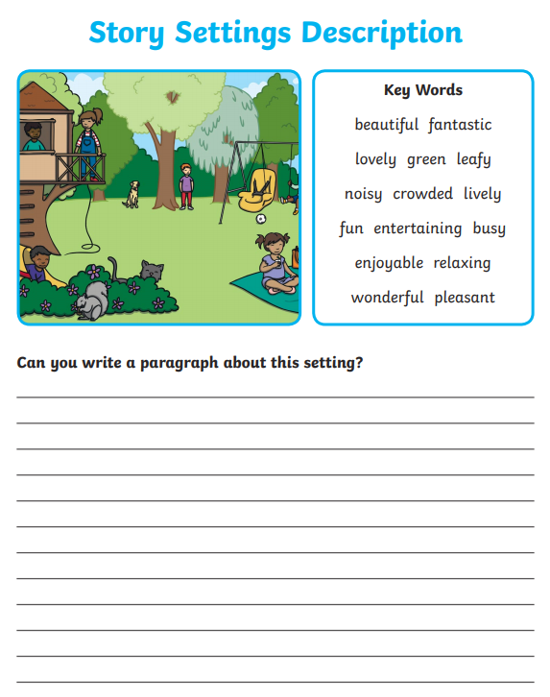

**_____________________________________________________________________________________________________________________________________________________________________________________________________________________________________________________________________________________________________________________________________________________________________________________________________________________**

Use the description for the monster and the setting to write your own story! Be as creative as you can.

05-01-2021

**_____________________________________________________________________________________________________________________________________________________________________________________________________________________________________________________________________________________________________________________________________________________________________________________________________________________**