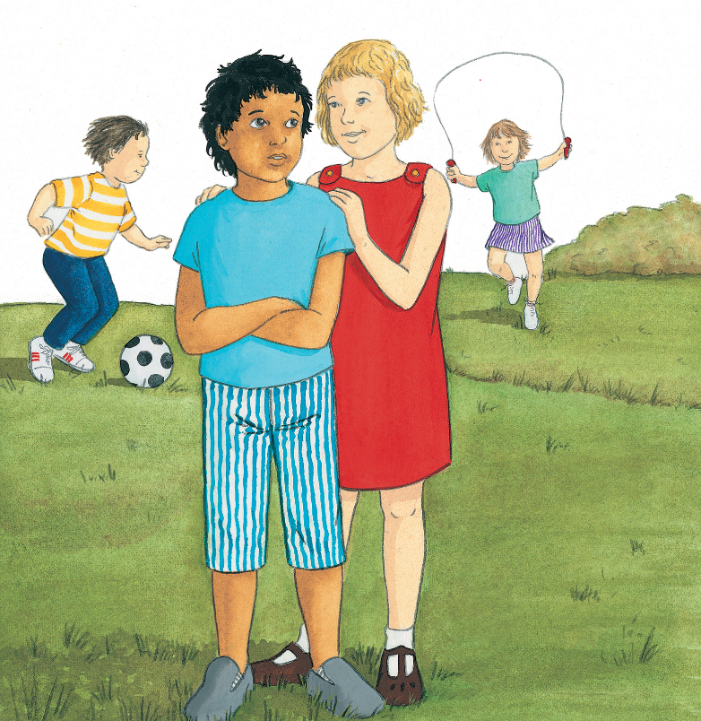

- What do you think has happened in the picture?
- How do you think the boy and the girl feel?
- What choice do you think the girl made?
- When have you had to make choices like that?
- What good choices have you made?
- How did you feel?
- What happens when you make a wrong choice?
- How do you feel, then? How can you try to make it right?

