15.01.21

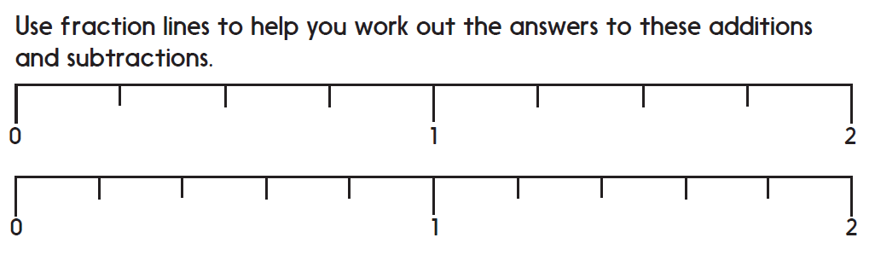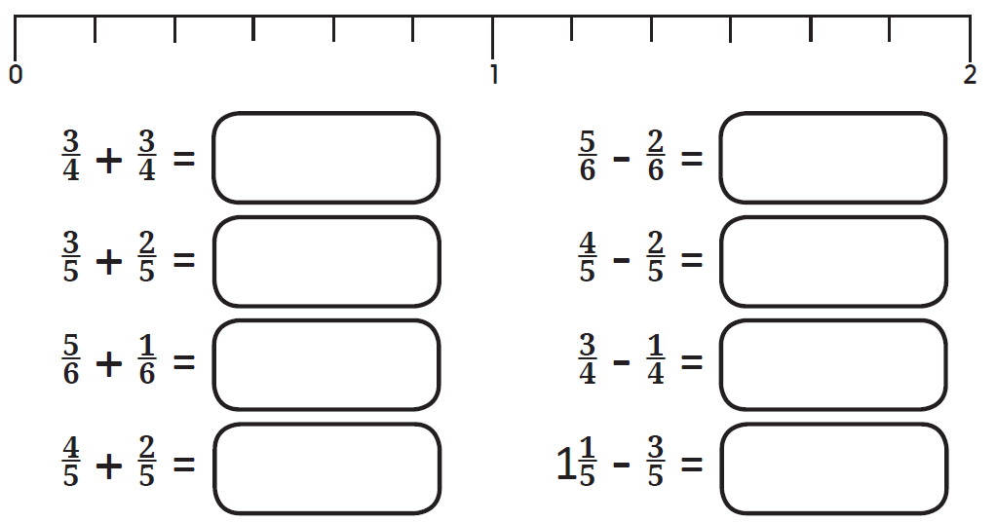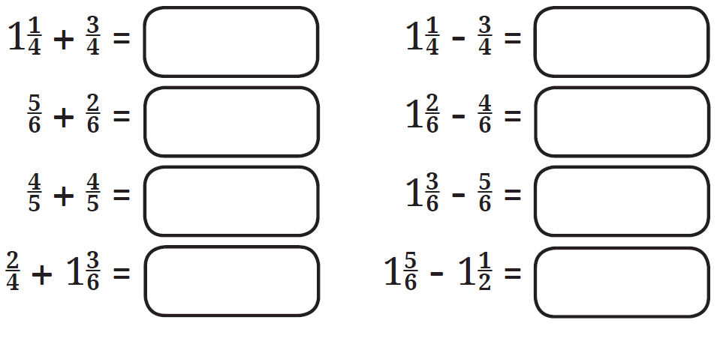**Challenge**

**Make up at least 4 new additions and subtractions.**