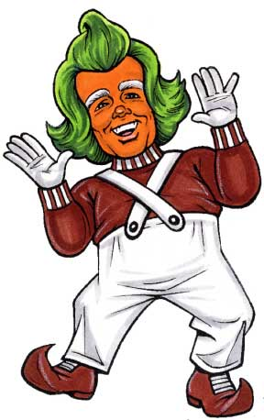
His hair is as …….
His legs are ……
His shoes are ….
He smells like ….
His skin is …..
Now write about the Oompa Loompas using adjectives.

