Home Learning Activities – Year 5
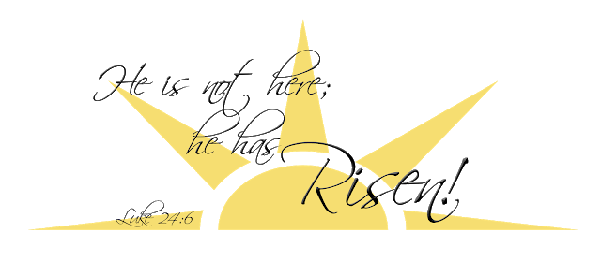
Monday 13th – Friday 17th April

Hi again everyone,
I hope that you and your families are well and had a happy and holy Easter.
Here are some additional activities, for what should be the 2nd week of the School Easter Holiday, in case you have completed all of the activities from last week.
The activities for this week include:
- Reading Scales Challenge Cards - this pack involves converting between different units of measurement.
A useful link:
www.schoolsofkingedwardvi.co.uk/ks2-maths-year-5-3b-measurement-measurement-conversion
Answers, for this pack, will be revealed next week.

- Fix the sentences – Your turn to be the teacher with these 5 correction activities. Check each sentence with care and re-write it correctly, thinking carefully about spellings and sentence punctuation. The answers are included at the end of the pack (so try not to peak at the answers until you’ve finished! 😉).

I’ll be back in touch, with even more activities, as well as the answers to this week’s first activity, next week. Don’t forget to look at our school’s website, under the ‘Home School’ tab for additional resources. Make sure that you keep reading and learning your times table facts. Also – if there is any work that you would like to share with me and the rest of the school community, then please email it to admin@stsaviours.lewisham.sch.uk with the heading “Home School” and then keep a look out for it on the school website, in the ‘Home School Gallery’ tab.
My continued best wishes are sent to you all – you all remain in my thoughts and prayers.
Miss Kelly

