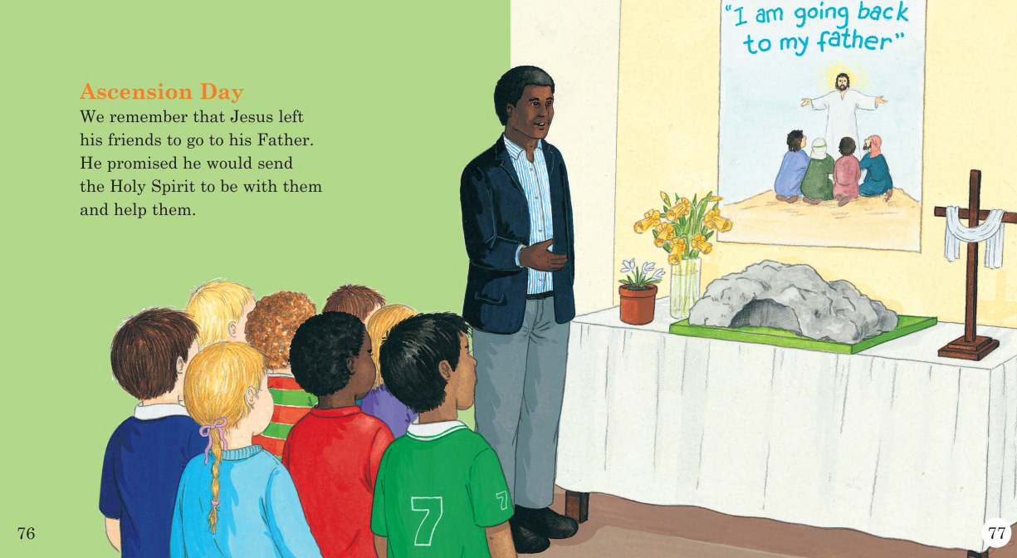

This week I would like you to make a Happy Holy day card, think of different Holy symbols that you can use to design your card. Use the picture above to help you.

