Use the column addition method to work out the number sentences. Remember to use your fingers if you need to!
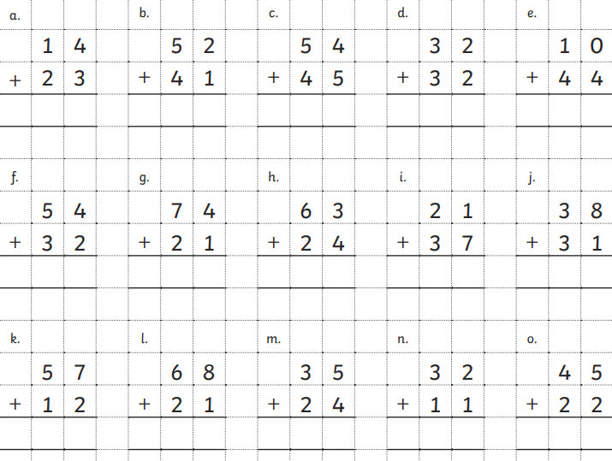

Challenge:
Now try answering these number sentences using column subtraction:

85 - 10 = 89 - 14 = 67 - 22 =

56 - 15 = 56 - 11 = 75 - 32 =

