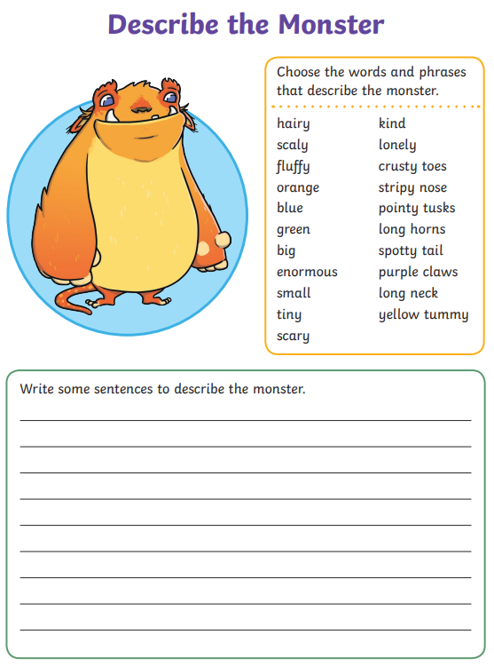

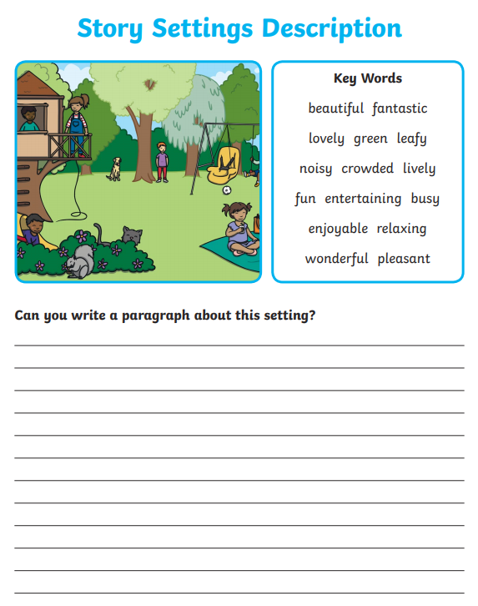

Use the description for the monster and the setting to write your own story! Be as creative as you can.

**_____________________________________________________________________________________________________________________________________________________________________________________________________________________________________________________________________________________________________________________________________________________________________________________________________________________**