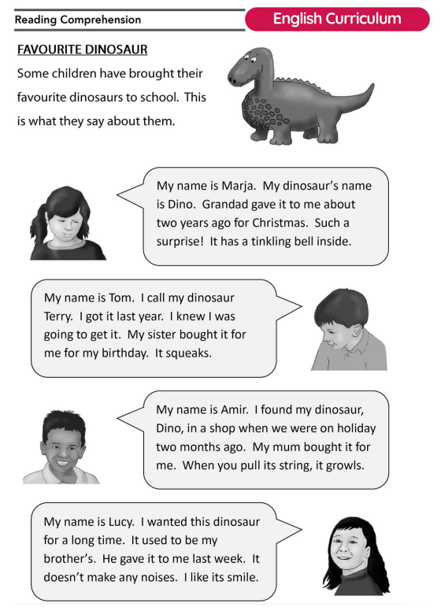

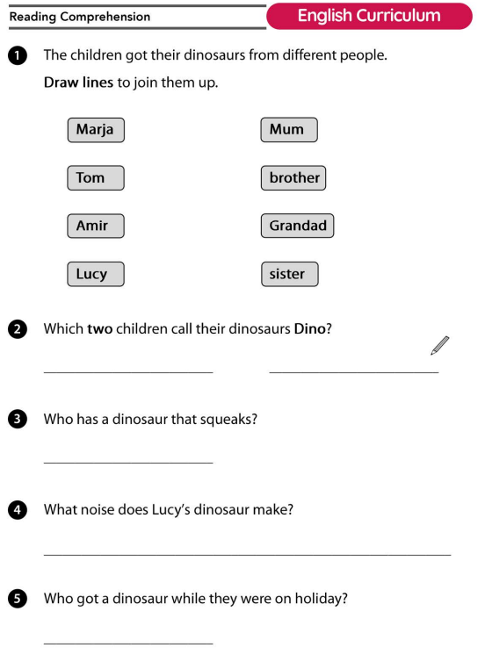

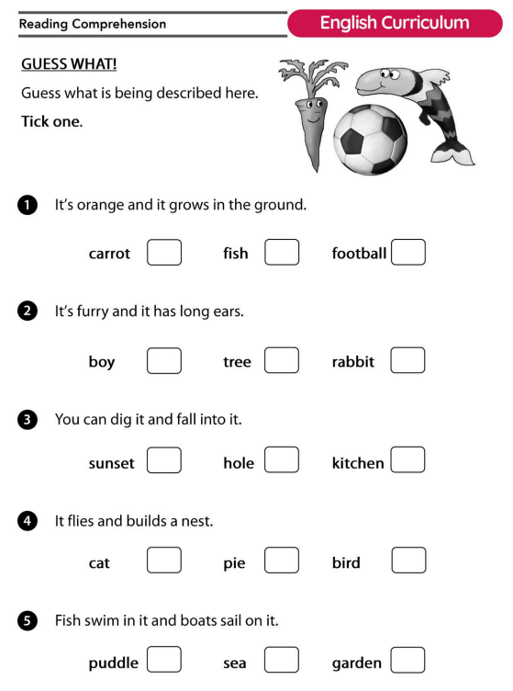

Think of an object or a thing, anything you want!
I want you to write three sentences about the object/thing you’re thinking about.
Once you have written your sentences read them out to your family and see if anyone can guess what it is.

For example Mrs Squire is thinking of an object.
Here are my three sentences…
- My object can be made from different materials like wood, metal and plastic.
- You normally find my object next to a table.
- You can sit on it.
What is it?

Now it’s your turn!

