Endings spelt sion | If the ending sounds like /zion/, it is spelt as –sion. | division, invasion, confusion, decision, collision, television, vision, excursion, exclusion, delusion, conversion, omission, possession, extension, admission, passion, occasion, confession, conclusion, impression, expression, permission, provision, session, supervision, mansion, discussion, expansion, explosion

- We had a lovely ______________ about World War 2.
- Don’t forget to write your ____________ at the end of your essay.
- I had to make a quick _____________ about which coat to take.
- When I get home, I will sit in front of the ____________ all night.
- I have a ____________ for water sports.
- He does a good ________________ of Tom Cruise.
- I heard a massive _____________ in the distance.
- The _____________ was led by Germany into France.
- When you finish, complete the ____________ on page 6.
- In art, we looked at facial ____________.
- I live in a huge ____________ by a river.
- I only eat cake on a special _____________ like my birthday.
Write a paragraph using as many of today’s spellings as possible. Remember to punctuate correctly. Can you use more complex punctuation?

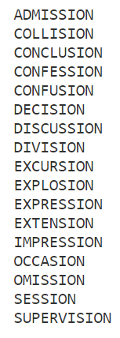
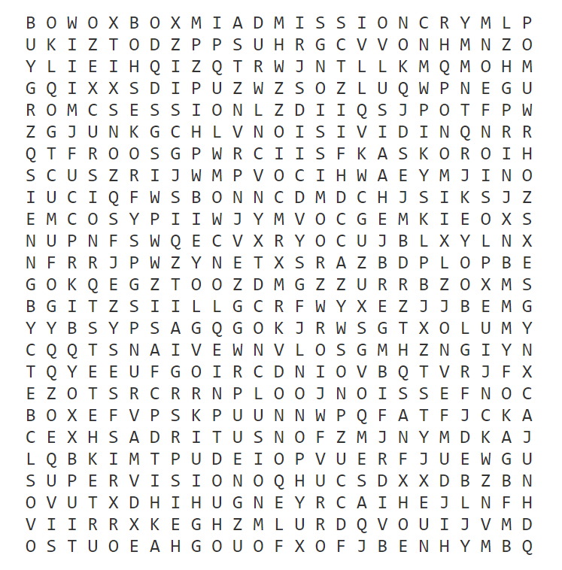

Super SPAG Challenge!
- Write a sentence including a preposition and one of today’s spellings.
- Write a sentence using a contraction for possession and two of today’s spellings.
- Write a sentence including an expanded noun phrase and one of today’s words.
1.)

2.)

3.)

