A note to parents: Direct speech is punctuated with inverted commas which are sometimes called speech marks or quotation marks. They are placed around direct speech to show the reader what a person says. Inverted commas can be either: single ‘ ‘ or double “ “.
“What’s for lunch?” asked Sally.
The inverted commas are placed around the speech (including the punctuation) and are usually followed – or preceded by – a reporting clause. This is the part of the sentence that tells the reader who is speaking, such as ‘asked Sally’.

Comic Strip Speech

Hold on tight! I’ll save you!
I will protect the castle from the dragon!
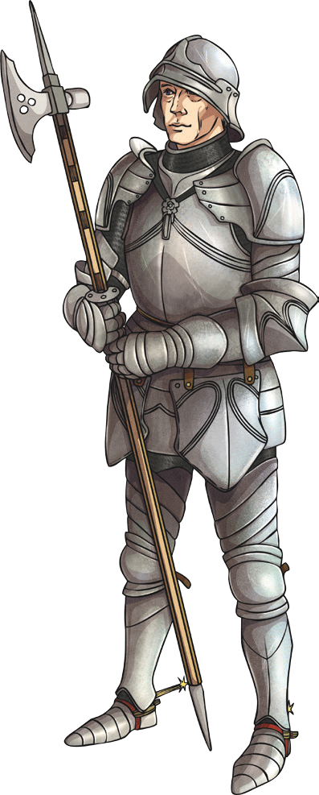

Using Inverted Commas to Show Direct Speech

Look at the comic strip speech bubbles below. Change each speech bubble into a speech sentence with inverted commas. The first has been done for you.

Hold on tight! I’ll save you!

The superhero flew through the air and shouted, “Hold on tight! I’ll save you!”
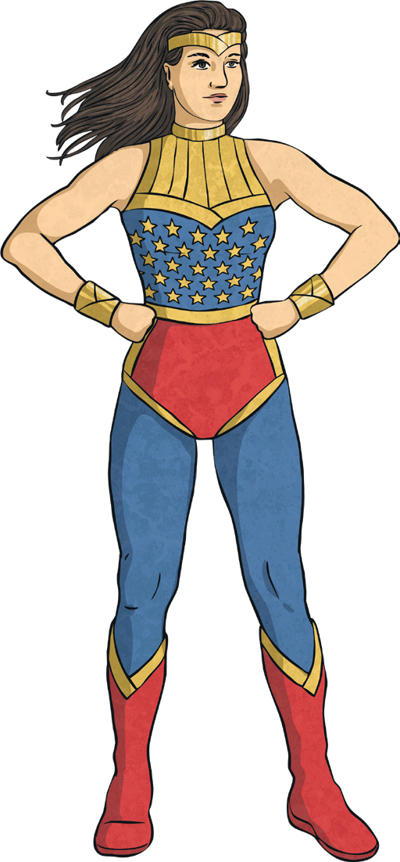

I wonder what treasures I’ll find in the sunken ship?
I wonder how I solve this problem.

Take out your books and write the date please.

To be or not to be? That is the question.

Are you ready to order?
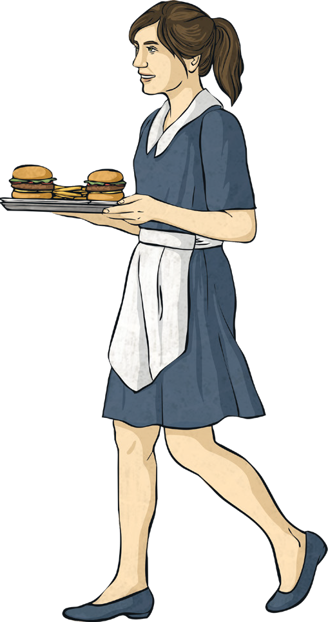

It’s safe to cross the road now.

