

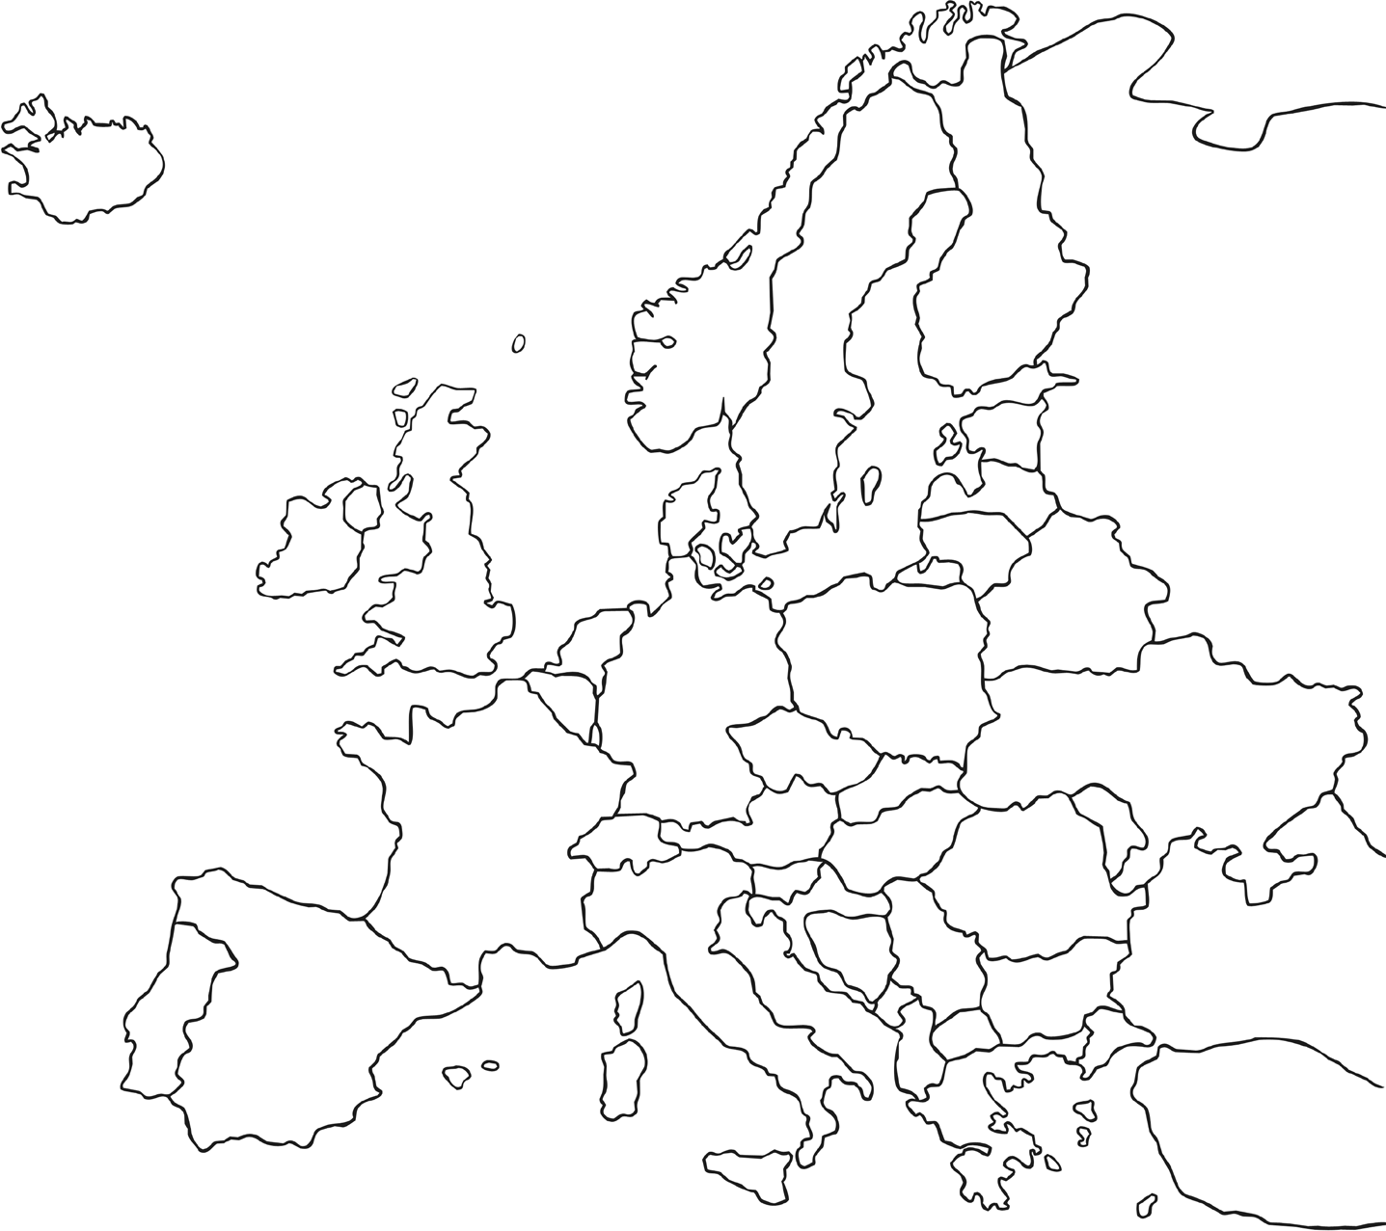

Map of Europe

History | UKS2 | Ancient Greece | Who Were the Ancient Greeks? | Lesson 1

Can you label any of the countries in Europe?



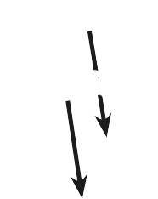

Map of Europe Answers

History | UKS2 | Ancient Greece | Who Were the Ancient Greeks? | Lesson 1

**Czech Rep.**

**Serbia**

**Portugal**

**Sweden**

**Norway**

**Hungary**

Can you label any of the countries in Europe?

Estonia Lithuania

Finland

Russia

Denmark

Netherlands Latvia

Ireland United Belgium

Kingdom Belarus

Poland

Germany

Switzerland Ukraine

France Austria

Italy Romania

Spain Bulgaria

Kos

Alb

Turkey

Slovenia

Greece

Macedonia