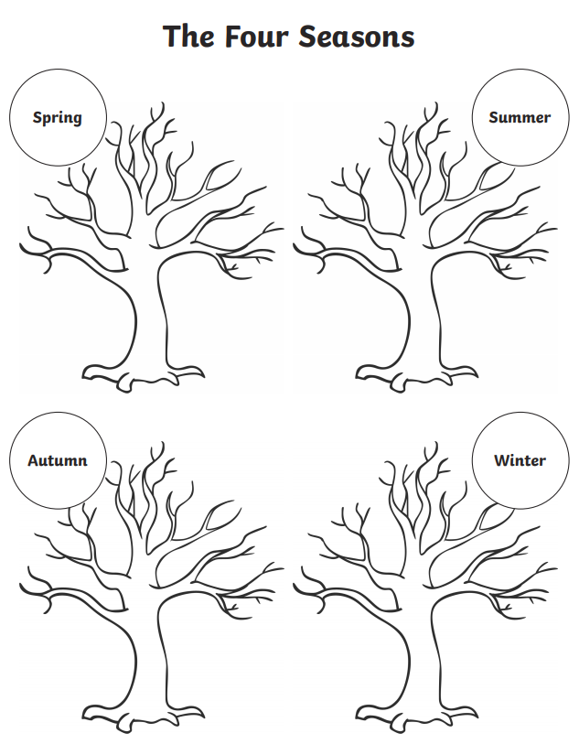

Which is your favourite season and why?

____________________________________________________________________________________________________________________________________________________________________________________________________________________________________________________________________________________________________________________________________________________________________________________________________________________________________________________________________________________________________________