Home Learning Activities – Year 5
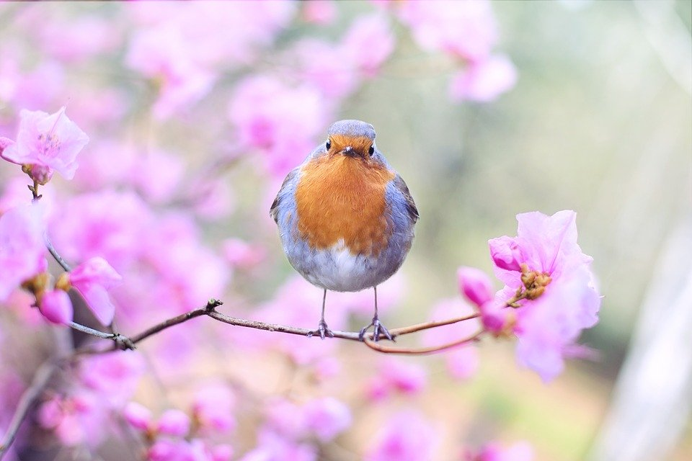
Monday 27th April - Friday 1st May
Hi again everyone,
I hope that you and your families are well.
With each passing day, we get one day closer to life returning to normal – that’s something that I hold on to very much. In the meantime, enjoy the time with your loved ones and cherish them, just as they cherish you.
Here is your work for this week:
Monday 27th April
- English
Facts about Greece Reading Comprehension
This pack contains three different levels of reading comprehension exercise which are marked with either 1, 2 or 3 stars – the greater the number of stars, the more challenging the task. Make sure that you select one that will challenge you rather than one that you find easy. Remember to read the text before attempting the questions. When answering the questions, remember to refer back to the text – it isn’t a test of memory. (The answers to questions are included – so try not to peak until you’ve finished! 😉).

- Maths
Top Marks Mental Maths Challenge
Select ‘addition’ (five-digit numbers). Aim to work on level 4, 5 or 6. You can set the ‘question interval’ to suit yourself – that's the gap between each question, for you to calculate the answer.
www.topmarks.co.uk/maths-games/daily10

- Topic
Map of Europe
As we continue our topic of Ancient Greece, we take some time to do some geography relating to Europe, as this is the continent that Greece is in (and the UK too).

Take a look through this website, which contains a range of interesting facts about the continent of Europe:
www.kids-world-travel-guide.com/europe-facts.html

If you are able to print out the blank map of Europe, from the list of resources, then do so – if you can’t, then maybe you could draw your own map of Europe. How many countries can you label on the map?

Now take a look at this interactive map of Europe – how many countries did you label correctly? Add in the names of any countries that you didn’t include on your map. Remember that country names should begin with a capital letter.
www.yourchildlearns.com/europe_map.htm

Tuesday 28th April
- English
SPaG (Spelling & Grammar) Activity
This pack contains three different levels of SPaG activities which are marked with either 1, 2 or 3 stars – the greater the number of stars, the more challenging the task. Make sure that you select one that will challenge you rather than one that you find easy. (The answers to questions are included – so no peaking until you’ve finished! 😉).

- Maths
Multiplication and Division Learning from Home Booklet
Common Factors - pages 4 & 5

If you are not able to print out the activity sheet, then record the questions and answers on a piece of paper.

If you need a reminder about common factors, then take a look at the following clip:
www.youtube.com/watch?v=1oQTriXR_Iw
Answers, for these questions, will be revealed next week.

- Topic
Flags of Europe
Take a look at this website about Europe and read through the information. Then, in the section subtitled ‘Countries of Europe’ click on the country names to discover what each countries’ flag looks like:
www.ducksters.com/geography/europe.php

Now, complete this quiz – how many of the European countries’ flags can you remember?
www.ducksters.com/games/europe_flags_map_game.php

Wednesday 29th April
- English - writing task part 1
Read the following extract from ‘Dragon Rider’ by Cornelia Funke:
www.worldbookday.com/wp-content/uploads/2017/11/Primary-Extract-Dragon-Rider.pdf

Design your own dragon – draw a picture of it. Maybe you could make a mode l of your dragon using recycled materials. (Please remember to ask an adult, in your home, before using anything.)

- Maths
Multiplication and Division Learning from Home Booklet
Finding Prime Factors – page 6

If you are not able to print out the activity sheet, then record the questions and answers on a piece of paper.

If you need a reminder about prime factors, then take a look at the following clip:
www.youtube.com/watch?v=tW97UU01ShY
Answers, for these questions, will be revealed next week.

- Creative Learning
Secret Code Maths Challenge
Make up a secret code with a key (e.g. A = 1, B = 2 etc. or draw a symbol for each letter). Write a message for a family member or to send it to a friend. Don’t forget to give them a copy of the key so that they can translate your message!

Thursday 30th April
- English – writing task part 2
i) Make sure that you have finished your design for a dragon (and model, if you started one) from Wednesday.
ii) Write a descriptive paragraph about your dragon’s appearance, trying to use a range of sentence starters, so that your paragraph doesn’t sound repetitive, as well as a selection of ‘wow’ words, throughout.
Use this online thesaurus to find more exciting word choices for commonly used words (e.g. instead of ‘happy’ I can use the word ‘delighted’).
www.collinsdictionary.com/dictionary/english-thesaurus

To use this online thesaurus, type the word that you want to find a ‘wow word’ for, into the long white rectangle which has ‘English Thesaurus’ typed in it – you will then be given a list of synonyms for you to choose from.

- Maths
Multiplication and Division Learning from Home Booklet
Prime Numbers – pages 7 & 8

If you are not able to print out the activity sheet, then record the questions and answers on a piece of paper.

If you need a reminder about prime numbers, then take a look at the following clip:
www.youtube.com/watch?v=rzAY1MFnYBI
Answers, for these questions, will be revealed next week.

- Topic/Art
On Tuesday, you explored the flags of European countries. What features did they have in common?
Take ideas from the flags, which you explored, to design your own flag – once you’ve designed it, maybe you could make a larger version of it. Recycled materials could be useful for this e.g. the inside of a finished cereal box – if you carefully deconstruct the net, you have a large piece of card to use for this or any other project you might wish to do. I’d love to see your flag designs, so don’t forget to share them and any other work that you’ve done, so that it can be put on our school’s website (see details below).

Friday 1st May
- English – writing task part 3
Write a non-chronological report (information text) about your new species of dragon. Make sure that your report includes a main title, introduction, subheadings (appearance, diet, habitat, behaviour, life span) and a labelled diagram.
If you would like a reminder about the features of a non-chronological report, then take a look at the following clip:
www.youtube.com/watch?v=t4rNkcTqT6I

- Maths
Multiplication and Division Learning from Home Booklet
Long Multiplication Practice – pages 9 & 10

If you are not able to print out the activity sheet, then record the questions and answers on a piece of paper.

If you need a reminder about long multiplication, then take a look at the following clip:
www.youtube.com/watch?v=RVYwunbpMHA
Answers, for these questions, will be revealed next week.

- Topic/Art
I hope you enjoyed your virtual visit to The British Museum last week and managed to track down some Ancient Greek artefacts. This week you’re going to get creative as I’m asking you to design your own Greek pot. But before you get designing, take a look at this information about why pots were so important to the Ancient Greeks:
www.ancientgreece.co.uk/dailylife/explore/exp_set.html

Then explore the different pot shapes that existed and what they were used for:
www.ancientgreece.co.uk/dailylife/explore/pot_shapes.html

Inspired by all that you’ve read, now have a go at designing your own Ancient Greek pot. What shape will it be? What will the main image be? Which geometric patterns will it include?

Miss Kelly’s riddle of the week

What question can you never answer yes to?

I’ll be back in touch, with more work, next week, as well as the answers to this week’s Maths activities and of course ‘Miss Kelly’s Riddle of The Week’.
Don’t forget to look at our school’s website, under the ‘Home School’ tab for additional resources. Make sure that you keep reading and learning your times table facts. Also – if there is any work that you would like to share with me and the rest of the school community, then please email it to admin@stsaviours.lewisham.sch.uk with the heading “Home School” and then keep a look out for it on the school website, in the ‘Home School Gallery’ tab.
My continued best wishes are sent to you all – each and every one of you remain in my thoughts and prayers.
Miss Kelly

