Home Learning Activities – Year 5
Monday 20th - Friday 24th April
Hi again everyone,
I hope that you and your families are well.
Monday 20th April should have seen us all excitedly returning to school, after the Easter Holiday, to start the final term of the school year – the Summer Term. It seems such a long time since I saw you all and I miss you all very much – but I look forward to when we will all be together again. Keep smiling and counting your blessings – there is so much we have to be grateful for, even at this difficult time.
Here is your work for this week:
Monday 20th April
- English
Year 5 Grammar Booklet
Commas in complex sentences - page 18, tasks 1 & 2

If you need a reminder about using commas within sentences, then take a look at the following clip:
www.youtube.com/watch?v=Wk0k2FLjM1c

- Maths
Year 5 Learning Pack
Multi-step problems – pages 9 & 10 (Labelled ‘E’ in a star)

If you need a reminder about solving multi-step problems, then take a look at the following clip:
www.youtube.com/watch?v=kn8frIzQupA

- Topic
Ancient Greece Timeline ordering
This term, we begin a new topic - Ancient Greece. So, to get started with this brilliant topic, you are challenged to create an Ancient Greece Timeline. If you are not able to print out the activity, then write out the dates, in the correct order, then copy the pictures which accompany each date in Ancient Greek history. (PLEASE NOTE: Ancient Greece was a period of history that was B.C. - Before Christ, so think VERY carefully about how you order these events)

If you need a reminder about organising B.C. and A.D. events on a time line, then take a look at the following clip:
www.youtube.com/watch?v=BKbDy09JZ6I

Tuesday 21st April
- English
'Who’s the best footballer on the planet?’ Reading Comprehension

- Maths
Year 5 Learning Pack
Multi-step problems – pages 11 & 12 (Labelled ‘GD’ in a star)

If you need a reminder about solving multi-step problems, then take a look at the following clip:
www.youtube.com/watch?v=kn8frIzQupA

- Science
Try these fun and easy science experiments with water! Watch Konnie Huq, in this clip, and join in with the fun and learn about scientific concepts as you do:
www.youtube.com/watch?v=LGJu-60zaK8

Wednesday 22nd April
- English/Topic part 1 (Research)
Continuing with our Ancient Greece topic, your next challenge is to create an A-Z of Ancient Greece. Can you find a word/name/event for every letter of the alphabet that relates to Ancient Greece?
Make sure, while you complete this research part of the activity, that you make notes about the word/name/event that you select for each letter.
e.g. A – Athena (Greek goddess of wisdom, crafts & war), B- Battle of Marathon (Took place in 490 BC between the citizens of Athens)...and so on, all the way to the letter z.

- Maths
Times Table Games
Select from the range of activities – if you are not able to print out any of the sheets that are required, then maybe you could neatly draw out the grid yourself and customise it, before you play.

- Creative Learning
Try to make a boat, which floats successfully in a container of water and can carry a cargo of at least one penny. (You can decide on the materials to use to make the boat – but make sure that you check with an adult first.) Hold a competition with other people in your household – which boat can carry the most pennies before it sinks?

Thursday 23rd April
- English/Topic part 2 (Research & presenting)
i) Continue with the activity from Wednesday - making sure that you have no blanks in your Ancient Greece A-Z
ii) Present the findings, from your research, as beautifully as you can, adding suitable pictures and information about each name/word/event.

Here’s an example, of one that somebody did for Ancient Egypt, to inspire you:

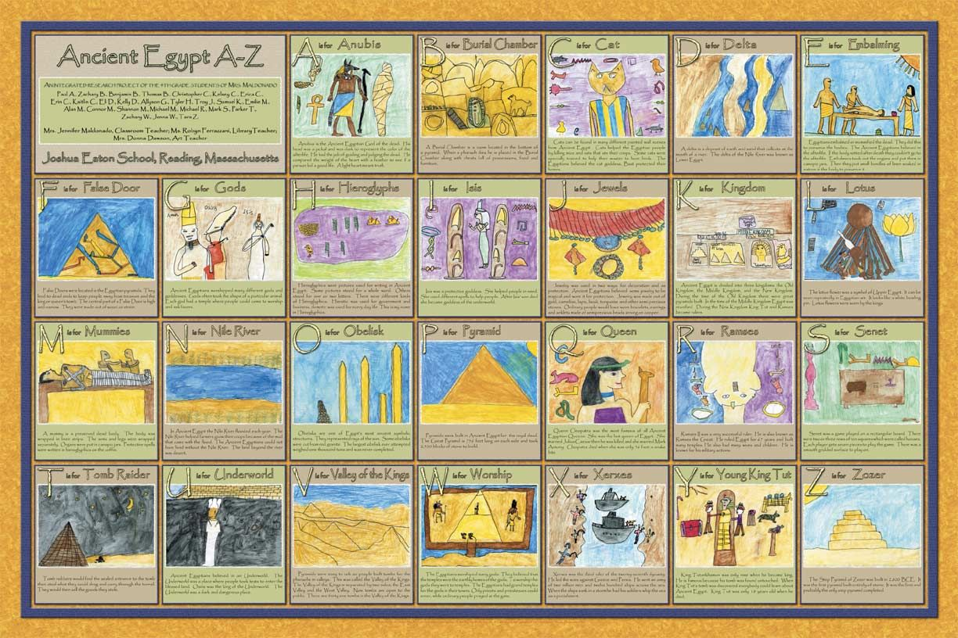

- Maths Year 5 Learning Pack
Multiplying and Dividing Word Problems – page 14
If you need a reminder about solving multiplying & division word problems, then take a look at the following clip:
www.youtube.com/watch?v=igpVebLCD8k

- Topic
Take a look at this website to find out about the Greek alphabet:
www.ducksters.com/history/ancient_greece/greek_alphabet.php
Now, have a go at completing the ‘Greek Alphabet’ activity sheet – can you write the names of the Greek gods & goddesses in Greek? If you are not able to print out the activity sheet, then record the names on a piece of paper.

Friday 24th April
- English
i) Watch the story Chaperon Rougeon Literacy Shed.
www.literacyshed.com/chaperon-rouge.html
ii) Write a diary entry for the main character, from Chaperon Rouge, and her journey. Think about how she is feeling. In your writing try very carefully to show rather than tell the reader how the character is feeling. (e.g. rather than writing that a character was ‘scared’, I might write: My quivering legs struggled to move forward, as I crept towards the unknown.)

If you would like a reminder about the features of a diary entry, then take a look at the following clip:
www.youtube.com/watch?v=BGL1EX4nXXI

- Maths
Times Table Games
Select a different game from the range of activities – if you are not able to print out any of the sheets that are required, then maybe you could neatly draw out the grid yourself and customise it before you play.

- Topic
Even though we have all been advised to stay at home – you can get that ‘school trip feeling’ by going on a virtual visit to The British Museum:
artsandculture.google.com/streetview/british-museum/AwEp68JO4NECkQ?sv_lng=-0.1266024509257022&sv_lat=51.51905368906714&sv_h=326&sv_p=0&sv_pid=JeKwUFYAMWXNWPh3IOg3jw&sv_z=1.0000000000000002

(Alternatively, type STREET VIEW BRITISH MUSEUM into a search engine, to access it.)

Can you find any Ancient Greek items in the museum? See if you can find some Greek pots & vases, as well as The Parthenon Gallery. What was The Parthenon? If you don’t know, perhaps you could do some research to find out. Try not to get lost in the museum! 😉

I’ll be back in touch, with more work, next week, as well as any answers to this week’s English & Maths activities. Don’t forget to look at our school’s website, under the ‘Home School’ tab for additional resources. Make sure that you keep reading and learning your times table facts. Also – if there is any work that you would like to share with me and the rest of the school community, then please email it to admin@stsaviours.lewisham.sch.uk with the heading “Home School” and then keep a look out for it on the school website, in the ‘Home School Gallery’ tab.
My continued best wishes are sent to you all – each and every one of you remain in my thoughts and prayers.
Miss Kelly

