Home Learning Activities – Year 5
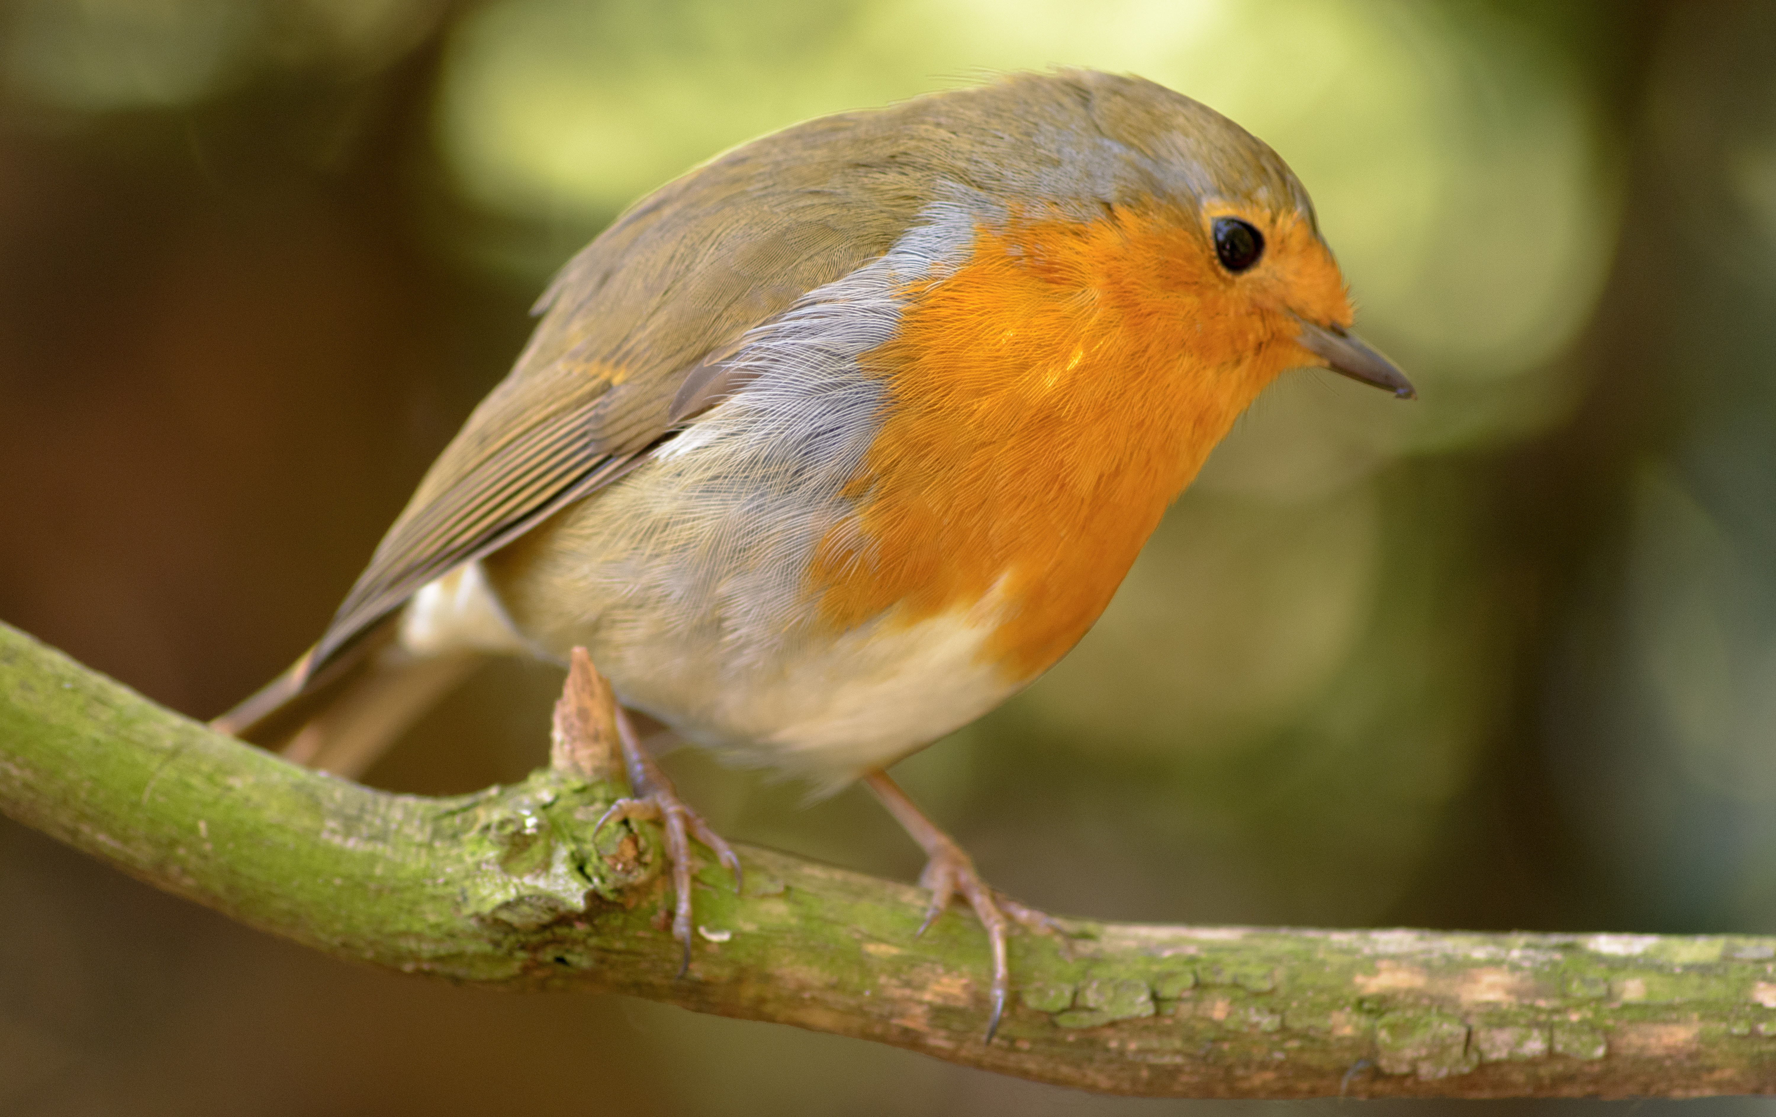
Monday 11th - Friday 15th May
Hi again everyone,
I hope that you and your families are well.
So much has changed in all of our lives, it can be hard, at times, to keep positive – but rather than focussing on the things that we can’t do right now, let’s try to focus on the wonderful people and things that we DO have in our lives. I found this poem, which has a great message for us all and when I think about each of your smiling faces, it puts the biggest smile on my face – so thank you!
A smile is quite a funny thing,
It wrinkles up your face,
And when it's gone, you never find
Its secret hiding place.
But far more wonderful it is
To see what smiles can do;
You smile at one, he smiles at you,
And so one smile makes two.
He smiles at someone since you smiled,
And then that one smiles back;
And that one smiles, until in truth
You fail in keeping track.
Now since a smile can do great good
By cheering hearts of care,
Let's smile and smile and not forget
That smiles go everywhere!
Here is your work for this week:
Monday 11th May
- English
See ‘English Activity Day 1’, in this week’s resource list.

- Maths
Top Marks Mental Maths Challenge
Select ‘ordering’ - aim to work on level 4, 5 or 6. You can set the ‘question interval’ to suit yourself – that's the time gap, between each question, for you to calculate the answer.
Remember, when we order numbers, it is important to compare like for like digit, so think carefully about place value as you order each set of numbers. Also, make sure that you read the question carefully, so that you know whether you have to order in ascending order (from smallest to largest) or in descending order (from largest to smallest):
www.topmarks.co.uk/maths-games/daily10

- Topic - Science
The Diet of Animals
In Science, we will be exploring the amazing animal kingdom (which, of course, includes humans). If you’d like to, you can join Steve Backshall, T.V.’s wildlife presenter and explorer, every Wednesday morning at 9:30am, for a live wildlife lesson, at:
www.youtube.com/channel/UCm-URP49TgSgyIU1rgh2m7A
For today’s task, look at the diet information sheet, listed in this week’s resources, which lists the eating habits of a variety of animals. Use this information to complete the Venn Diagram, to organise each animal, as to whether they are a herbivore, a carnivore or an omnivore. If you are unable to print out the sheets, you can neatly draw your own Venn Diagram, onto a piece of paper, then either draw or write the name of each animal, in the correct section.
For information about the diets of different animals, take a look at this video clip:
www.bbc.co.uk/bitesize/topics/zn22pv4/articles/z846gdm
For a reminder about Venn Diagrams, take a look at this clip:
www.youtube.com/watch?v=CkV_uRErIqk

Tuesday 12th May
- English
See ‘English Activity Day 2’, in this week’s resource list.

- Maths
Multiplication and Division Learning from Home Booklet
Multiplying multiples of 10 by 1 digit numbers – pages 16 & 17

If you are not able to print out the activity sheet, then record the questions and answers on a piece of paper.

If you need a reminder about multiplying multiples of 10 by 1 digit numbers, then take a look at the following clip:
www.youtube.com/watch?v=iOsysghGhPg
The answer pack, for these questions, is included in this week’s resource list – no peeking until you’ve completed all of the questions though! 😉

- Topic
Ancient Greek Number System
Become an expert at using the Ancient Greek number system with this activity (see activity sheet in this week’s resource list). If you are not able to print out the activity sheet, then record the questions and answers on a piece of paper. When you finish this activity, perhaps you could make an Ancient Greek number system challenge for someone else in your home to solve.

Wednesday 13th May
- English
See ‘English Activity Day 3’, in this week’s resource list.

- Maths
Multiplication and Division Learning from Home Booklet
Short division – pages 18 & 19

If you are not able to print out the activity sheet, then record the questions and answers on a piece of paper.

If you need a reminder about short division, then take a look at the following clip:
www.youtube.com/watch?v=FApcjdAhnrY
The answer pack, for these questions, is included in this week’s resource list – no peeking until you’ve completed all of the questions though! 😉

- D.T./Creative Learning
Marble/Ball run challenge
Your challenge is to create a free-standing marble/ball run, in which the marble/ball takes as close to 10 seconds as possible to travel from the top to the bottom.
Recycled materials will be great for this challenge – empty cardboard boxes and plastic bottles – please check with an adult before using anything, though.
See the PDF document, in this week’s resources list, for suggestions for creating your marble/ball run.

Thursday 14th May
- English
See ‘English Activity Day 4’, in this week’s resource list.

- Maths
Multiplication and Division Learning from Home Booklet
Division word problems, interpreting answers – pages 20 & 21

If you are not able to print out the activity sheet, then record the questions and answers on a piece of paper.

In these word problems, you will need to ‘interpret the remainder’ and decide whether the answer needs to be rounded up or down.
Make sure that you take time to read each question with care, underlining any key words and numbers, as you go. When calculating each answer, show your full workings, then decide whether the answer to the calculation needs to be rounded up (to the next whole number) or rounded down (ignore the remainder) by referring back to the question. Finally, clearly record the final answer to the word problem, remembering to put it in to context (what does this number represent? e.g. glasses/ pots.)

If you need a reminder about interpreting the remainder in division word problems, then take a look at the following clip:
www.youtube.com/watch?v=i5eNRi5ktgM
The answer pack, for these questions, is included in this week’s resource list – no peeking until you’ve completed all of the questions though! 😉

- Topic
Ancient Greek Gods & Goddesses
Your task is to gather facts about the Ancient Greek gods and goddesses, in order to create a set of cards, which you can play a game of Top Trumps with. If you’re not sure what Top Trump cards are or how to play the game then take a look at this web page for details:

www.toptrumps.com/how-to-play-top-trumps/

To gather facts about the Greek gods & goddesses for your Top Trump cards, read through ‘Facts about The Greek Gods & Goddesses sheet, from this week’s resource list. Also, take a look at these two websites:
www.bbc.co.uk/bitesize/topics/z87tn39/articles/zgt7mp3

www.natgeokids.com/uk/discover/history/greece/greek-gods/

Once you’ve gathered all of your facts, you will need to decide upon the categories which you will use for the Top Trump cards - these should be the same for the entire set. (Numerical values are best for each category.) Here’s an example:

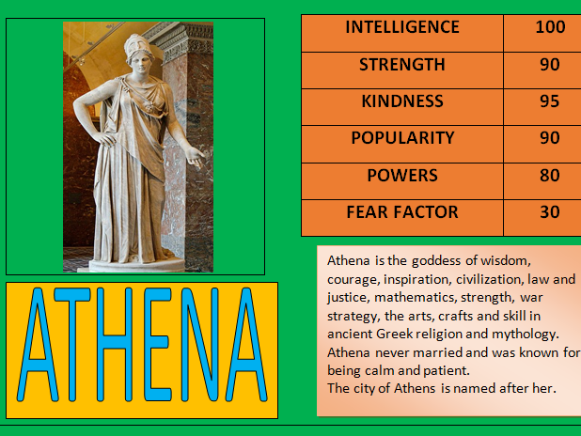
As soon as you’ve decided upon the categories, you will need to decide on the scores (out of 100) which you will assign to each god or goddess, for each given category, using the facts that you have collected.

Now you are ready to create your pack of Top Trump cards – you can use the template in this week’s resource list or design your own. Make sure that you include a picture of each god or goddess and get creative by decorating your pack of cards. Finished? Find a partner, in your home, to play a game of Ancient Greek Gods & Goddesses Top Trumps! Hope you enjoy it.

Friday 15th May
- English
See ‘English Activity Day 5’, in this week’s resource list.

- Maths
Multiplication and Division Learning from Home Booklet
Multiplying and Dividing Whole Numbers by 10 – pages 22 & 23

If you are not able to print out the activity sheet, then record the questions and answers on a piece of paper.

If you need a reminder about multiplying and dividing whole numbers by multiples of 10, then take a look at the following clip:
www.youtube.com/watch?v=QIz_uBz9woM
The answer pack, for these questions, is included in this week’s resource list – no peeking until you’ve completed all of the questions though! 😉

- Art/Creative Learning
Texture Treasure Hunt
- Use the following link to access this art lesson:
www.thenational.academy/year-5/foundation/texture-treasure-hunt-year-5-wk1-5
- Click 'Start Lesson' and watch the video that introduces the activity
- When finished, click 'Next activity'
- Now, complete the task according to the instructions.

Examples of finished work from this activity:
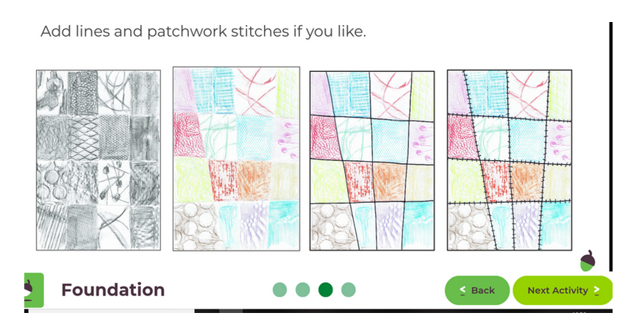

Scholastic Reading Pro Library
I hope that you’ve managed to read some e-books, using the Scholastic Reading Pro library. See the school website for information, if you haven’t logged in yet:
www.stsaviours.lewisham.sch.uk/home_school/scholastic-home-reading-library/
A big well done to Chinazo, Ciaran and Johnny for reading some of the books, from the Scholastic Reading Pro Library, keep up the hard work!

I’ve added two new books, based upon our Ancient Greece topic, for you to enjoy. The titles are:
  - The Odyssey – an adaptation of Homer’s epic poem, in a cartoon strip format.
  - The Odyssey – another adaptation of Homer’s poem, in a story format.
Please try to read at least one of these versions, as well as any other books of your choice.

Miss Kelly’s riddle of the week
What happens once in a lifetime, twice in a moment, but never in one hundred years?

Answer to last week’s riddle:
Q. When things go wrong, what can you always count on?
  - Your fingers. (Although, bonus team points if you thought the answer was Miss Kelly!)
Did you solve it? Well done if you did!
👍

I’ll be back in touch, with more work, next week, as well as the answer to ‘Miss Kelly’s Riddle of The Week’.
Don’t forget to look at our school’s website, under the ‘Home School’ tab for additional resources. Make sure that you keep reading and learning your times table facts. Also – if there is any work that you would like to share with me and the rest of the school community, then please email it to admin@stsaviours.lewisham.sch.uk with the heading “Home School” and then keep a look out for it on the school website, in the ‘Home School Gallery’ tab.
My continued best wishes are sent to you all – each and every one of you remain in my thoughts and prayers.
Cheerio and keep smiling!
Miss Kelly

