This optical illusion lets you turn two pictures into one. Did you know your brain uses short cuts in order to process all the millions of things we see at any one time? An optical illusion “tricks” your eyes and brain.
What you need:
- white cardboard
- pencils and colouring pens
- scissors
- Glue/sellotape
Instructions
Cut out two shapes from a sheet of white cardboard.
Draw whatever you want, but we tried some fish on one piece and the tank on the other.
Glue or sellotape a pencil in between the two pictures.
Hold the pencil between your palms and rub your hands to make the picture spin around.
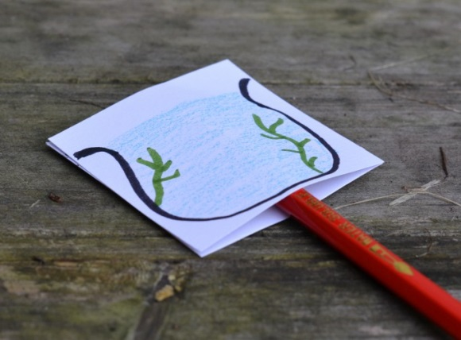
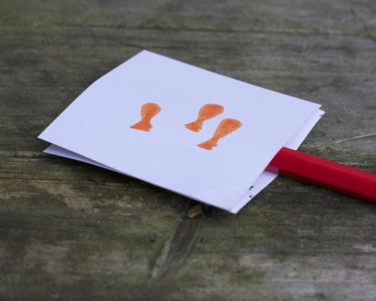
If you are finished, have a go at another optical illusion from the website below.
