These questions are about the Matilda – (Page 1 and 2)

1) Underline a phrase that shows how the children starting school were feeling. (1 mark)
Miss Honey was a mild and quiet person who never raised her voice and was seldom seen to smile, but there was no doubt she possessed that rare gift for being adored by every small child under her care. She seemed to understand totally the bewilderment and fear that so often overwhelm young children who are for the first time are herded into a classroom and told to obey orders. Some curious warmth that almost intangible shone out of Miss Honey’s face...

2) The author describes Miss Trunchball as a “gigantic holy terror, a fierce tyrannical monster.” Why does the author use this phrase? (2 marks)
_________________________________________________________________________________________________________________________________________________________
3) If she fell over she would smash into a thousand pieces, like a p porcelain figure.

What does this phrase tell us about Miss Honey? (2 marks)
_________________________________________________________________________________________________________________________________________________________
4) She ploughed right on through them like a tank...

What does the word ploughed tell us? (2 marks)
_________________________________________________________________________________________________________________________________________________________
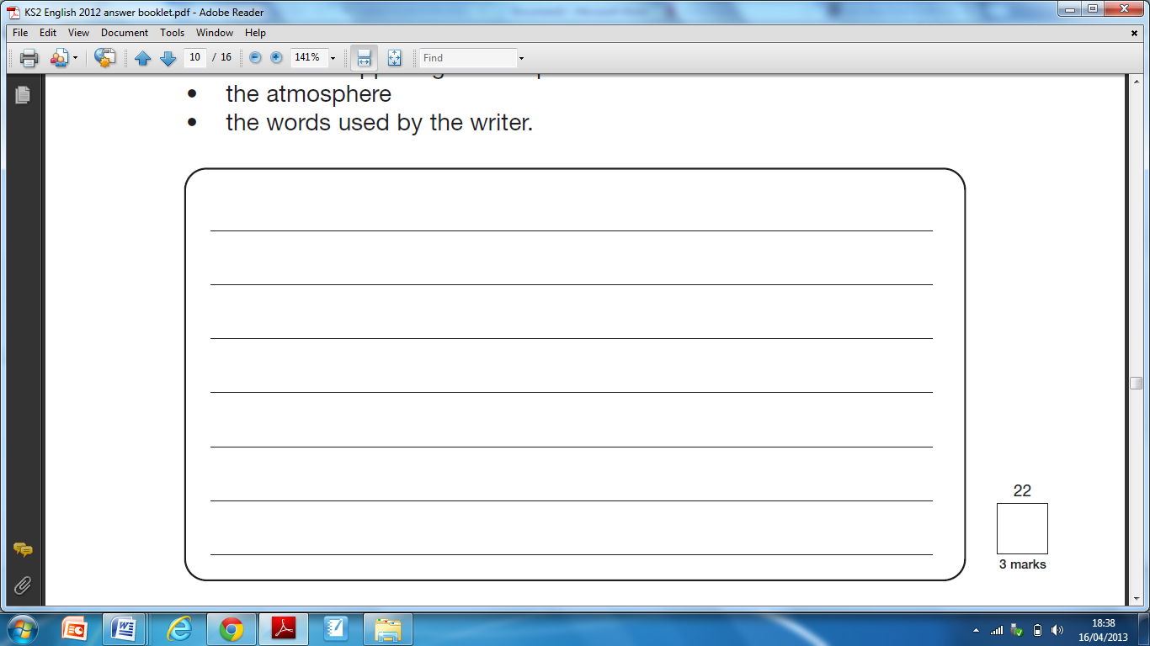
4) Trunchball is an unlikeable and dangerous character. Give three things on page 1 that support this view. (3 marks)
5) What does “marched like a storm trooper with long strides and waving arms” tell us about how Miss Trunchball moved? (2 marks)
_________________________________________________________________________________________________________________________________________________________
6) Why is Miss Trunchball compared to an enraged rhinoceros? (2 marks)
______________________________________________________________________________________________________ 7) What do the words Crunchem and Bleak tell us about the school? (2 marks) ______________________________________________________________________________________________________
8) If you get on the wrong side of Miss Trunchbull she can liquidise you like a carrot in a kitchen blender.

What does the author mean by this phrase? (2 marks)
______________________________________________________________________________________________________
9) What type of story is this? (1 mark)
Tick one
A fantasy story
An adventure story
A traditional tale
A mythical story
10) Trunchball and Miss Honey are very different characters. How does the author create a different picture of each character? Explain fully. (3 marks)

11) Matilda was both clever and brave in the story.
How was he clever? Give one way. (1 mark)
1. ___________________________________________ __________________________________________________
How was he brave? Give one way. (1 mark)
1. ___________________________________________ __________________________________________________
12) Match each of the events listed below to the word which best describes his feelings at the time. (2 marks)
Curious
Children sit in Miss Honey’s class.
Distraught
Children see Miss Trunchball marching in the corridor,

Relaxed
Miss Honey hears Matilda reciting her 2 times table.
Newcomers arrive at the school.
Bewildered
Miss Honey asks whether Matilda knows two times four hundred and eighty-seven.
Surprised

13) Find and copy two words or phrases that show Miss Honey was shocked when hearing Matilda recite her times tables. (2 marks)
1) ________________________________________
2) _________________________________________

14) Complete the table to show whether you think Miss Honey would agree or disagree with each statement. (2 marks)

Statement | Agree or disagree
Never answer Miss Trunchball back.

Sometimes you have to raise your voice at a child.
Other times table are easier than the two times table.
Every child should be appreciated as an individual in their own right.

