Use the column addition method to work out the number sentences. Remember to use your fingers if you need to!
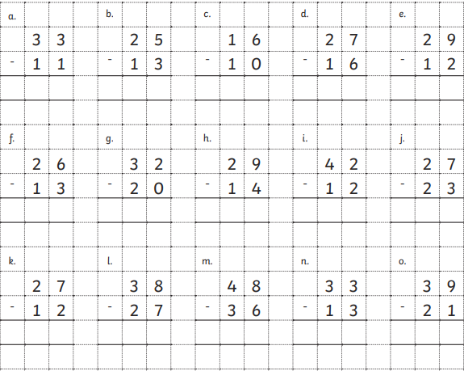

Challenge:
Now try answering these number sentences using column addition:

52 + 17 = 33 + 62 = 22 + 34 =

11 + 85 = 48 + 10 = 62 + 16 =

