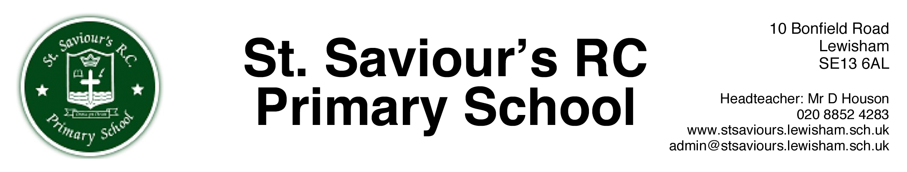

25th November 2016 dh/news7/autumn/emm

Dear Parents and Carers,

It has been a very busy start to the second half of Autumn Term and as ever, we have lots to update you with!

Sad News - It is my sad duty to announce that our much loved Business Manager Mrs Mason will be retiring at Christmas. Mrs Mason has been at the school 17 years and has worked under three different Headteachers and seen an awful lot of change in that time!
On a personal note I would like to place on record my unmeasurable thanks to Mrs Mason, who made my life so easy in those first couple of years, ensuring an extremely smooth handover. Also in more recent times the educational landscape has changed so much, and again, Mrs Mason’s support and loyalty cannot be questioned.
Mrs Mason, the school will never be the same without you sat behind that desk! You take with us our eternal gratitude and you will not be forgotten, and always in our prayers.

Parent Consultation on Electronic Payments - The results of the parent consultation on electronic payments are as follows –

47 Responses
40 in favour of using an electronic system for paying
7 against using an electronic system for paying

Obviously this is an extremely positive response for using an electronic system, so we will spend the Spring Term preparing for the switch to all electronic payments, which will then be implemented in the Summer Term 2017. Many thanks for all the responses.

After School Provision Consultation - Much like your views on electronic payment, we are now consulting your views on our after school hours provision. We would like your views on not only our extra club provision, but also our After School Club. Please could you ensure all responses are back by Friday 9th December (please place your responses in the black box in our foyer).
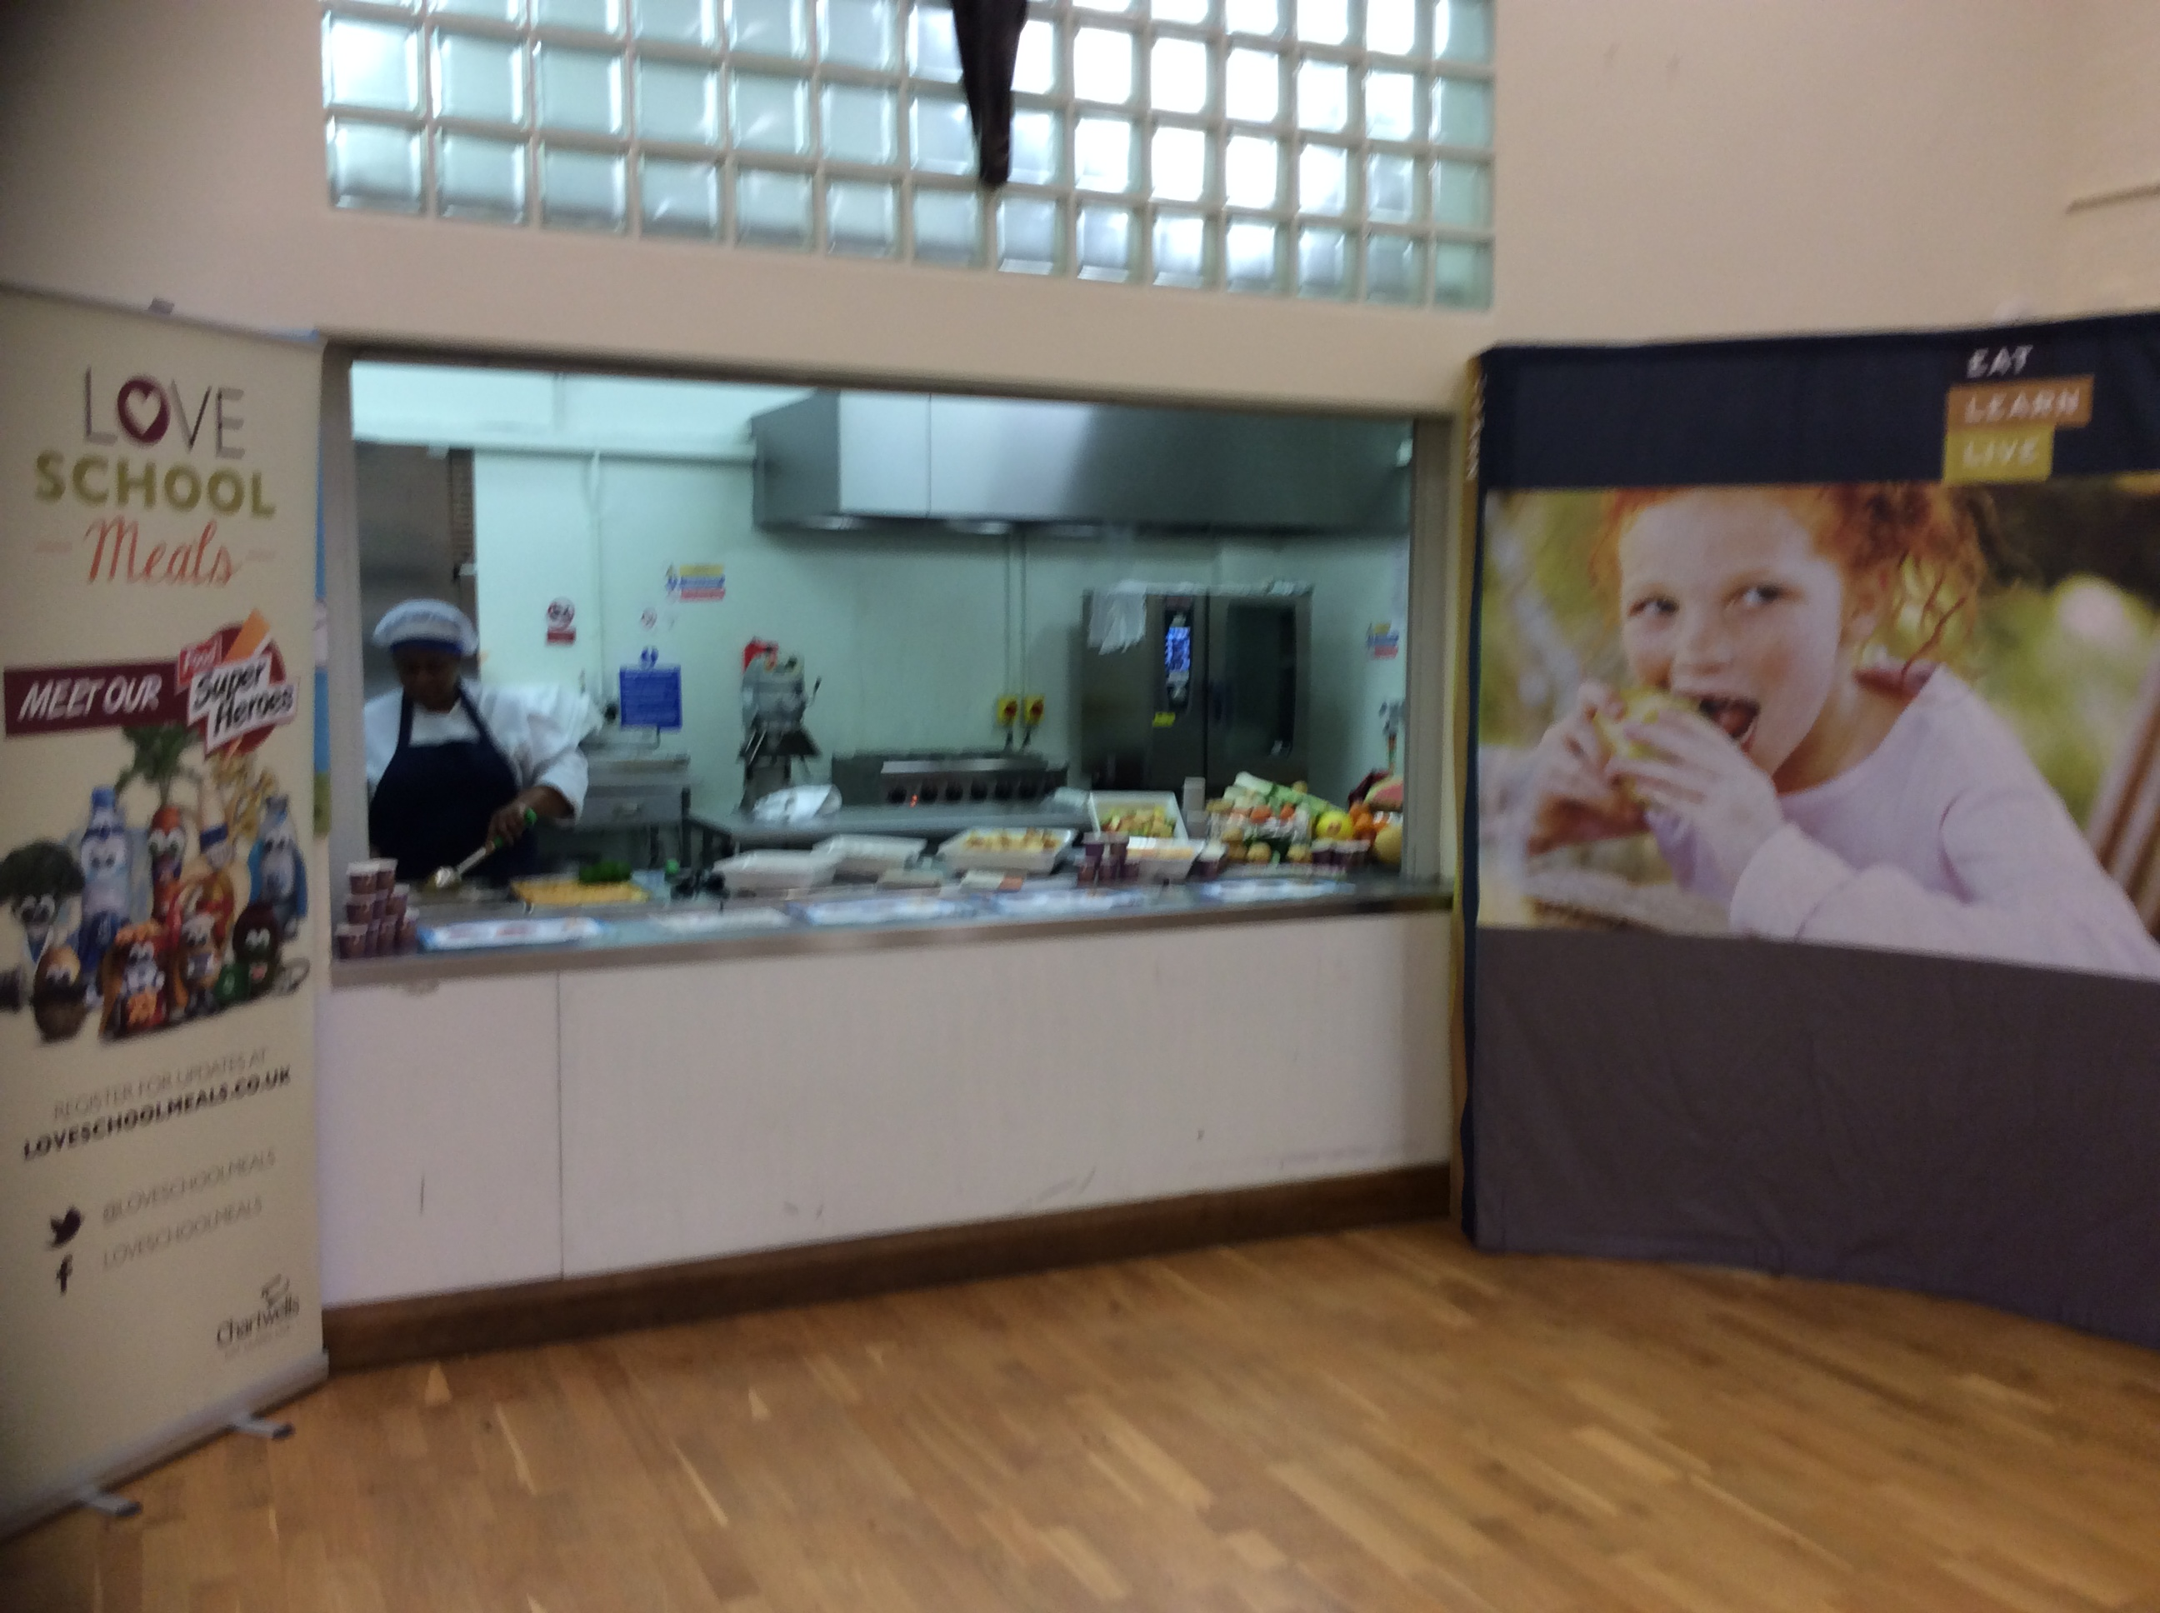
Parent’s Evening - It was wonderful to see so many of you at parents evening last week, we hope you found the experience productive and gained some insight into how your children are progressing.

We hope you also enjoyed the excellent food tasting event, provided by Chartwell’s. Heralda, our lovely chef, was hard at work into the early evening providing more great meals!

Again, we hope that you now have a better understanding of the meals and choices available for your children.
In the next newsletter I will tell you of some brilliant Nutrition and Cooking classes that Chartwell’s have offered us for later in the month and also into the Spring Term 2017.

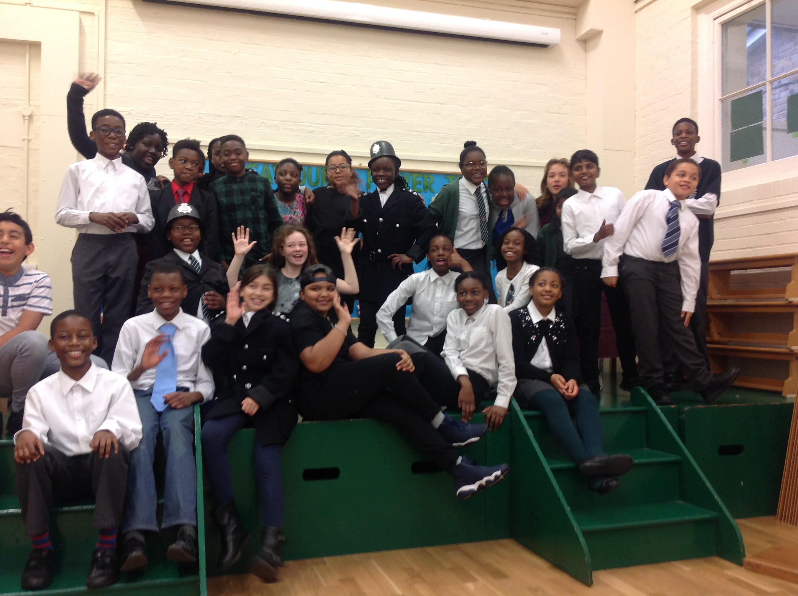
Class 6 Assembly
A big well done to our class 6 children performed their assembly this week on the Highway Man, their English topic in class currently.
The children not only performed brilliantly, but also wrote the script and directed it themselves, under Mr Chown’s watchful eye!

Pupil power!

Christmas Celebrations at St Saviour’s
I am pleased to confirm the dates and times for our EYFS/KS1 Nativity, KS2 Carol Concert and our Christmas Mass at the end of this newsletter.

Christmas Disco – Our Christmas Disco will be held on Friday 9th December in the School Hall (6.30 – 8.30pm) Tickets as usual available from the School Office on the form provided.
Please note that this year we are having a totally alcohol free Disco please do NOT bring any wine, beer or any form of alcopops etc into the school, this is unfortunately due to ‘unreasonable drinking levels’ at the End of Year Disco. Any person ignoring this request will be asked to leave. Thank you for your support in this matter.

Voluntary Fund – Thank you to the parents who have already returned their forms and donations for the School Voluntary Fund. These much appreciated donations provide items of equipment for the school that we would otherwise not be able to have, I am sure you will all agree that the hall projector and screen provided with last years’ fund have enhanced assemblies, meetings, presentations and school shows. Please support us and return your slips and monies as soon as possible.

Mr. D Houson
Headteacher

Diary Dates
29th Nov Choir perform at the Turning of the Year Festival, Blackheath
30th Nov Father Tom visiting classes
2nd Dec EYFS Open Day for prospective parents 2017/18
6th Dec KS2 Nutrition Classes provided by Chartwell’s
9th Dec Christmas Disco – admission by ticket only
12th Dec Choir Carol Singing at Lewisham Shopping Centre
13th Dec Choir Carol Singing at Bromley Shopping Centre
13th Dec EYFS/KS1 Nativity Performance at 2.00pm
14th Dec EYFS/KS1 Nativity Performance at 9.30am
14th Dec Father Tom visiting classes
15th Dec KS2 Carol Concert in St Saviour’s Church
16th Dec School Pantomime & Christmas Jumper Day
20th Dec Christmas Mass at St Saviour’s Church – Everyone welcome
Whole School Christmas Lunch
School closes for Christmas Holidays 2.00 p.m. NO After School Clubs
4th Jan School Closed for teacher training day
5th Jan Children return to school from the Christmas Holidays
10th Jan EYFS/KS1 Nutrition Classes provided by Chartwell’s

To be arranged – whole class cookery workshops provided by Chartwell’s

