Use the character builder to create your own character. Make you character as creative as you want.
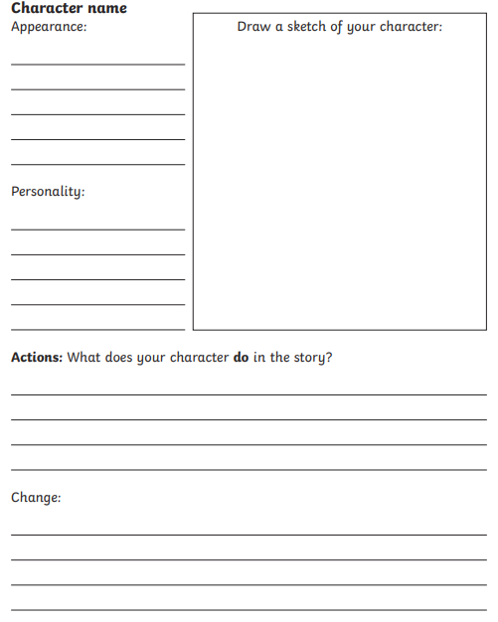

Now I want you to create a comic using the character you have designed!

